Parcel 96

  3675 Five Mile Rd, Town of Allegany

|  |  |  |  |  |  |  |  |  |  |  |
| --- | --- | --- | --- | --- | --- | --- | --- | --- | --- | --- |
| http://maps.cattco.org/imate/quickstream.aspx?file=VOLLOCAL/Rel2017/042089075004000105400000000007.jpg&thumb=true&width=201&height=152 | | | | | **Status:** | | Active | | | |
| **Roll Section:** | | Taxable | | | | | |
| **Swis:** | | 042089 | | | | | |
| **Tax Map ID #:** | | 75.004-1-54 | | | | | |
| **Property Class:** | | 210 - 1 Family Res | | | | | |
| **Site:** | | RES 1 | | | | | |
| **In Ag. District:** | | No | | | | | |
| **Site Property Class:** | | 210 - 1 Family Res | | | | | |
| **Zoning Code:** | | AF - Af-Forest Dist. | | | | | |
| **Neighborhood Code:** | | 20314 | | | | | |
| **Total Acreage/Size:** | | | 147.3 x 167 | | **School District:** | | Allegany - Limestone | | | | | | |
| **Land Assessment:** | | | 2017 - $9,800 | | **Total Assessment:** | | 2017 - $50,000 | | | | | | |
| **Full Market Value:** | | | 2017 - $51,546 | |  | |  | | | | | | |
| **Living Area:** | | | 2,822 sq. ft. | | **First Story Area:** | | | | 1,322 sq. ft. | | | | |
| **Second Story Area:** | | | 1,500 sq. ft. | | **Half Story Area:** | | | | 0 sq. ft. | | | | |
| **Finished Basement:** | | | 0 sq. ft. | | **Number of Stories:** | | | | 2 | | |
| **Building Style:** | | | Colonial | | **Bathrooms (Full - Half):** | | | | 1 - 1 | | |
| **Bedrooms:** | | | 5 | | **Kitchens:** | | | | 1 | | |
| **Fireplaces:** | | | 1 | | **Basement Type:** | | | | Full | | |
| **Porch Type:** | | | Porch-covered | | **Porch Area:** | | | | 306.00 | | |
| **Basement Garage Cap:** | | | 0 | | **Attached Garage Cap:** | | | | 576.00 sq. ft. | | |
| **Overall Condition:** | | | Fair | | **Overall Grade:** | | | | Average | |
| **Year Built:** | | | 1973 | |  | |  | | | |
| **Structure** | **Size** | | | **Grade** | | **Condition** | | **Year** | |
| Porch-covered | | 306.00 sq. ft. | | Average | | Normal | | 1973 | |
| Gar-1.0 attached | | 576.00 sq. ft.  MINIMUM BID $25,000 | | Average | | Normal | | 1973 | |

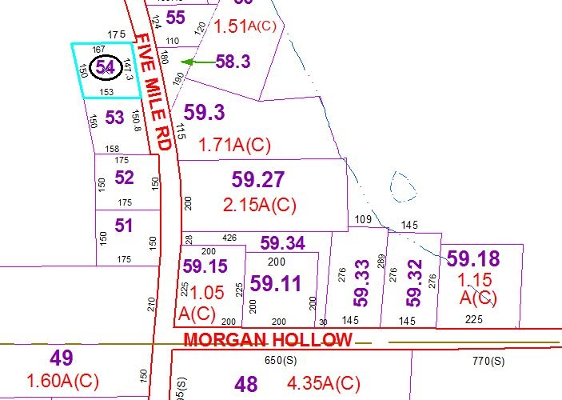

Approximate Yearly Taxes

School $881

Town/County $960

Total $1,841

Special Districts for 2015