Parcel 72

105 Jefferson St, City of Olean

|  |  |  |  |  |  |  |  |  |  |  |  |  |  |  |
| --- | --- | --- | --- | --- | --- | --- | --- | --- | --- | --- | --- | --- | --- | --- |
| http://maps.cattco.org/imate/quickstream.aspx?file=VOLLOCAL/Rel2017/041200094075000502700000000006.jpg&thumb=true&width=201&height=152 | | | | | | | **Status:** | | | | Active | | | |
| **Roll Section:** | | | | Taxable | | | |
| **Swis:** | | | | 041200 | | | |
| **Tax Map ID #:** | | | | 94.075-5-27 | | | |
| **Property Class:** | | | | 210 - 1 Family Res | | | |
| **Site:** | | | | RES 1 | | | |
| **In Ag. District:** | | | | No | | | |
| **Site Property Class:** | | | | 210 - 1 Family Res | | | |
| **Zoning Code:** | | | | - | | | |
| **Neighborhood Code:** | | | | 12205 | | | |
| **Total Acreage/Size:** | | | | 40 x 135 | | | **School District:** | | | | Olean | | | |
| **Land Assessment:** | | | | 2017 - $4,500 | | | **Total Assessment:** | | | | 2017 - $16,500 | | | |
| **Full Market Value:** | | | | 2017 - $18,539 | | |  | | | |  | | | |
| **Living Area:** | | | 1,440 sq. ft. | | | **First Story Area:** | | | | | | 720 sq. ft. | |
| **Second Story Area:** | | | 720 sq. ft. | | | **Half Story Area:** | | | | | | 0 sq. ft. | |
| **Finished Basement:** | | | 0 sq. ft. | | | **Number of Stories:** | | | | | | 2 | |
| **Building Style:** | | | Old style | | | **Bathrooms (Full - Half):** | | | | | | 1 - 0 | |
| **Bedrooms:** | | | 4 | | | **Kitchens:** | | | | | | 1 | |
| **Fireplaces:** | | | 0 | | | **Basement Type:** | | | | | | Full | |
| **Porch Type:** | | | Porch-enclosed | | | **Porch Area:** | | | | | | 192.00 | |
| **Overall Condition:** | | | Poor | | | **Overall Grade:** | | | | | | Economy | |
| **Year Built:** | | | 1916 | | |  | | |  | | | | |
| **Structure** | **Size** | | | | **Grade** | | | **Condition** | | **Year** | | |
| Porch-enclosed | | 8 × 24 | | | Economy | | | Poor | | 1916 | | |
| Porch-enclosed | | 6 × 12 | | | Economy | | | Poor | | 1916 | | |
| Carport | | 20 × 22 | | | Economy | | | Poor | | 1916 | | |
| Porch-open/deck | | 6 × 12  MINIMUM BID $2500 | | | Economy | | | Poor | | 1916 | | |

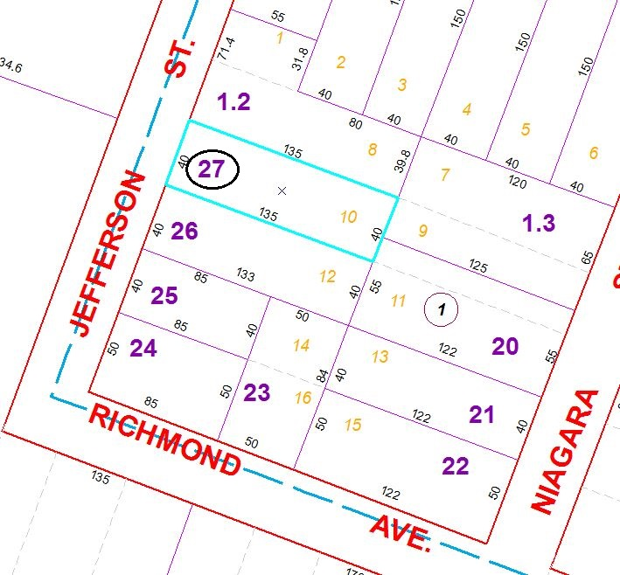

Approximate Yearly Taxes

School $431

City $241

County $230

Total $902

Special Districts for 2015