Parcel 356

Conewango Rd, Town of Randolph

|  |  |  |  |
| --- | --- | --- | --- |
| *No Photo Available* | | **Status:** | Active |
| **Roll Section:** | Taxable |
| **Swis:** | 047600 |
| **Tax Map ID #:** | 70.064-1-31.1 |
| **Property Class:** | 311 - Res vac land |
| **Site:** | RES 1 |
| **In Ag. District:** | No |
| **Site Property Class:** | 311 - Res vac land |
| **Zoning Code:** | - |
| **Neighborhood Code:** | 76010 |
| **Total Acreage/Size:** | 95 x 440 | **School District:** | Randolph |
| **Land Assessment:** | 2017 - $8,000 | **Total Assessment:** | 2017 - $8,000 |
| **Full Market Value:** | 2017 - $10,127  Approximate Yearly Taxes  School $100  Town/County $241  Total $341 |  |  |

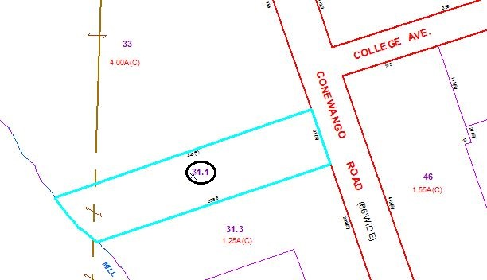

Special Districts for 2015