Parcel 300A

Enchanted Lake, Town of Napoli

|  |  |  |  |
| --- | --- | --- | --- |
| *No Photo Available* | | **Status:** | Active |
| **Roll Section:** | Taxable |
| **Swis:** | 046200 |
| **Tax Map ID #:** | 62.062-1-30 |
| **Property Class:** | 314 - Rural vac<10 |
| **Site:** | RES 1 |
| **In Ag. District:** | No |
| **Site Property Class:** | 314 - Rural vac<10 |
| **Zoning Code:** | - |
| **Neighborhood Code:** | 62030 |
| **Total Acreage/Size:** | 75 x 150 | **School District:** | Randolph |
| **Land Assessment:** | 2017 - $800 | **Total Assessment:** | 2017 - $800 |
| **Full Market Value:** | 2017 - $851  LANDLOCKED  Approximate Yearly Taxes  School $ 8  Town/County $17  Total $25 |  |  |

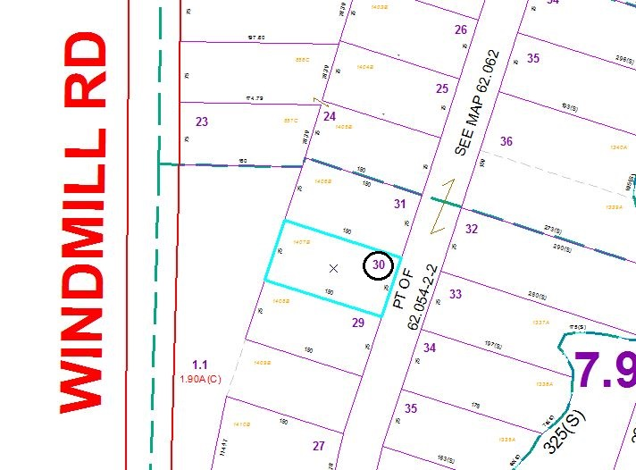

Special Districts for 2015