Parcel 208A

Mt Pleasant Ave, Village of Franklinville

|  |  |  |  |
| --- | --- | --- | --- |
| *No Photo Available* | | **Status:** | Active |
| **Roll Section:** | Taxable |
| **Swis:** | 044001 |
| **Tax Map ID #:** | 40.078-2-6 |
| **Property Class:** | 311 - Res vac land |
| **Site:** | RES 1 |
| **In Ag. District:** | No |
| **Site Property Class:** | 311 - Res vac land |
| **Zoning Code:** | - |
| **Neighborhood Code:** | 40150 |
| **Total Acreage/Size:** | 5 x 190.7 | **School District:** | Franklinville |
| **Land Assessment:** | 2017 - $200 | **Total Assessment:** | 2017 - $200 |
| **Full Market Value:** | 2017 - $299 |  |  |

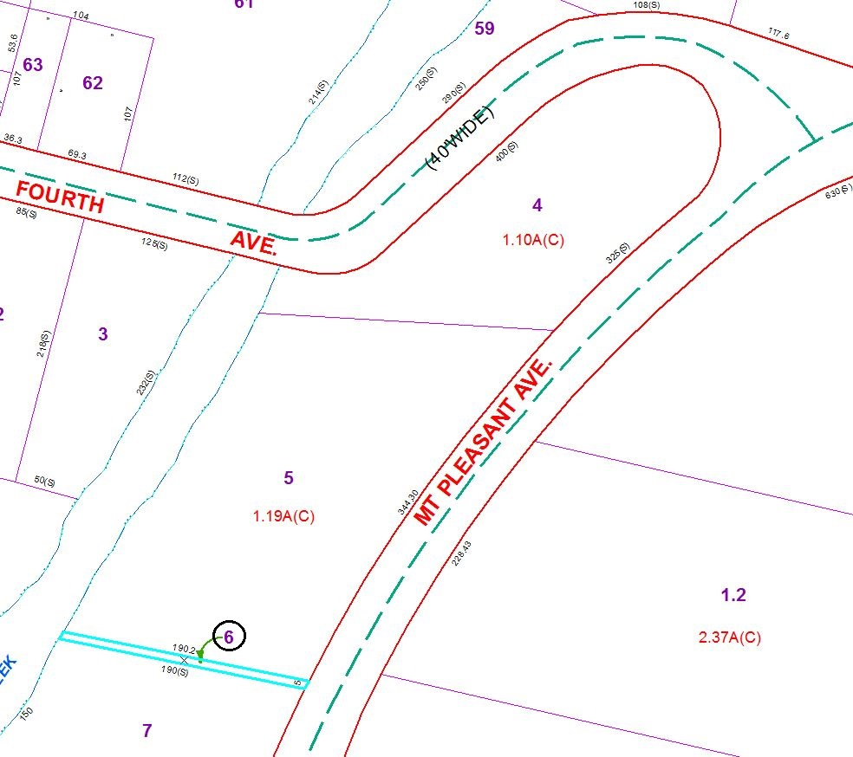

Approximate Yearly Taxes

School $5

Village $3

Town/County $6

Total $14

Special Districts for 2015