Parcel 152

75 First Ave, Village of South Dayton

|  |  |  |  |  |  |  |  |  |  |  |  |  |  |
| --- | --- | --- | --- | --- | --- | --- | --- | --- | --- | --- | --- | --- | --- |
| http://maps.cattco.org/imate/quickstream.aspx?file=VOLLOCAL/Rel2017/043001033033000602900000000004.jpg&thumb=true&width=201&height=152 | | | | | | **Status:** | | | Active | | | | |
| **Roll Section:** | | | Taxable | | | | |
| **Swis:** | | | 043001 | | | | |
| **Tax Map ID #:** | | | 33.033-6-29 | | | | |
| **Property Class:** | | | 210 - 1 Family Res | | | | |
| **Site:** | | | RES 1 | | | | |
| **In Ag. District:** | | | No | | | | |
| **Site Property Class:** | | | 210 - 1 Family Res | | | | |
| **Zoning Code:** | | | - | | | | |
| **Neighborhood Code:** | | | 30080 | | | | |
| **Total Acreage/Size:** | | | 120 x 150 | | | **School District:** | | | Pine Valley | | | | |
| **Land Assessment:** | | | 2017 - $3,100 | | | **Total Assessment:** | | | 2017 - $29,300 | | | | |
| **Full Market Value:** | | | 2017 - $29,300 | | |  | | |  | | | | |
| **Living Area:** | | 1,049 sq. ft. | | | **First Story Area:** | | | | | | 913 sq. ft. | |
| **Second Story Area:** | | 0 sq. ft. | | | **Half Story Area:** | | | | | | 136 sq. ft. | |
| **Finished Basement:** | | 0 sq. ft. | | | **Number of Stories:** | | | | | | 1.5 | |
| **Building Style:** | | Old style | | | **Bathrooms (Full - Half):** | | | | | | 1 - 0 | |
| **Bedrooms:** | | 2 | | | **Kitchens:** | | | | | | 1 | |
| **Fireplaces:** | | 0 | | | **Basement Type:** | | | | | | Crawl | |
| **Porch Type:** | | Porch-open/deck | | | **Porch Area:** | | | | | | 240.00 | |
| **Overall Condition:** | | Normal | | | **Overall Grade:** | | | | | | Economy | |
| **Year Built:** | | 1910 | | |  | | |  | | | | |
| **Structure** | **Size** | | | **Grade** | | | **Condition** | | | **Year** | |
| Porch-open/deck | 16 × 15 | | | Economy | | | Normal | | | 1986 | |
| Porch-covered | 225.00 sq. ft. | | | Economy | | | Normal | | | 1986 | |
| Barn-1.0 gen | 30 × 20 | | | Economy | | | Normal | | | 1987 | |

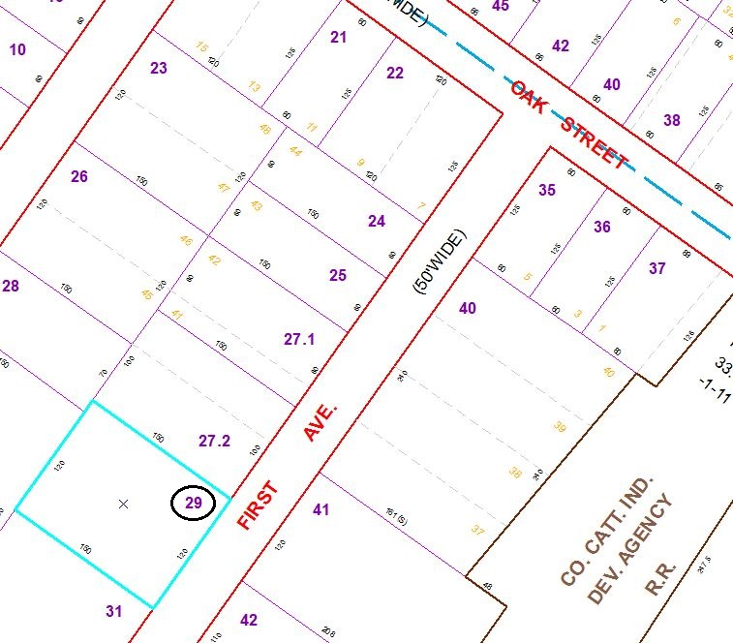

Approximate Yearly Taxes

School $647

Village $378

Town/County $552

Total $1,577

Special Districts for 2015