Parcel 132

440 Main St, Town of Carrollton

|  |  |  |  |  |  |  |  |  |  |  |  |  |  |  |  |  |  |
| --- | --- | --- | --- | --- | --- | --- | --- | --- | --- | --- | --- | --- | --- | --- | --- | --- | --- |
| http://maps.cattco.org/imate/quickstream.aspx?file=VOLLOCAL/Rel2017/042400110023000100800000000011.jpg&thumb=true&width=201&height=152 | | | | | | | | **Status:** | | | | Active | | | | | |
| **Roll Section:** | | | | Taxable | | | | | |
| **Swis:** | | | | 042400 | | | | | |
| **Tax Map ID #:** | | | | 110.023-1-8 | | | | | |
| **Property Class:** | | | | 421 - Restaurant | | | | | |
| **Site:** | | | | COM 1 | | | | | |
| **In Ag. District:** | | | | No | | | | | |
| **Site Property Class:** | | | | 421 - Restaurant | | | | | |
| **Zoning Code:** | | | | 01 | | | | | |
| **Neighborhood Code:** | | | | 24010 | | | | | |
| **Total Acreage/Size:** | | | | 2.64 | | | | **School District:** | | | | Allegany - Limestone | | | | | |
| **Land Assessment:** | | | | 2017 - $11,600 | | | | **Total Assessment:** | | | | 2017 - $84,000 | | | | |
| **Full Market Value:** | | | | 2017 - $97,674 | | | |  | | | |  | | | | |
| **Overall Eff Year Built:** | | | | 0 | | | | **Overall Condition:** | | | | Normal | | | | |
| **Overall Grade:** | | | | Average | | | | **Overall Desirability:** | | | | 3 | | | | |
| **AC%** | **Sprinkler%** | | **Alarm%** | | **Elevators** | | **Basement Type** | | **Year Built** | | **Condition** | | | **Quality** | **Gross Floor Area (sq. ft.)** | | | | **Stories** |
| 0 | 0 | | 0 | | 0 | |  | | 1920 | | Normal | | | Average | 3564 | | | | 2 |
| **Structure** | | **Size** | | | | **Grade** | | | | **Condition** | | | **Year** | | |
| Porch-covered | | 384.00 sq. ft. | | | | Economy | | | | Normal | | | 1998 | | |
| Porch-covered | | 10 × 7 | | | | Average  Approximate Yearly Taxes  School $1,701  Town/County $1,758  Total $3,459 | | | | Normal | | | 2015 | | |

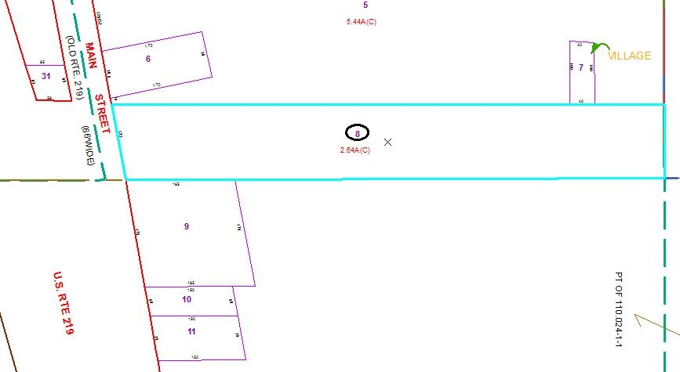

Special Districts for 2015