Parcel 8

217 Barry St S, City of Olean

|  |  |  |  |  |  |  |  |  |  |  |  |  |  |
| --- | --- | --- | --- | --- | --- | --- | --- | --- | --- | --- | --- | --- | --- |
| http://maps.cattco.org/Imate/quickstream.aspx?file=VOLLOCAL/Rel2016/041200094073000402500000000006.jpg&thumb=true&width=201&height=152 | | | | | | **Status:** | | | | | Active | | |
| **Roll Section:** | | | | | Taxable | | |
| **Swis:** | | | | | 041200 | | |
| **Tax Map ID #:** | | | | | 94.073-4-25 | | |
| **Account #:** | | | | | 002170 | | |
| **Property Class:** | | | | | 210 - 1 Family Res | | |
| **Site:** | | | | | RES 1 | | |
| **In Ag. District:** | | | | | No | | |
| **Site Property Class:** | | | | | 210 - 1 Family Res | | |
| **Zoning Code:** | | | | | - | | |
| **Neighborhood Code:** | | | | | 12203 | | |
| **Total Acreage/Size:** | | | 37.5 x 115 | | | **School District:** | | | | | Olean | | |
| **Land Assessment:** | | | 2016- $3,200 | | | **Total Assessment:** | | | | | 2016 - $58,000 | | |
| **Full Market Value:** | | | 2016- $63,043 | | |  | | | | |  | | |
| **Living Area:** | | 1,498 sq. ft. | | | **First Story Area:** | | | | | 892 sq. ft. | | |
| **Second Story Area:** | | 606 sq. ft. | | | **Half Story Area:** | | | | | 0 sq. ft. | | |
| **Building Style:** | | Old style | | | **Bathrooms (Full - Half):** | | | | | 1 - 0 | | |
| **Bedrooms:** | | 3 | | | **Kitchens:** | | | | | 1 | | |
| **Fireplaces:** | | 0 | | | **Basement Type:** | | | | | Partial | | |
| **Porch Type:** | | Porch-covered | | | **Porch Area:** | | | | | 84.00 | | |
| **Basement Garage Cap:** | | 0 | | | **Attached Garage Cap:** | | | | | 440.00 sq. ft. | | |
| **Overall Condition:** | | Normal | | | **Overall Grade:** | | | | | Average | | |
| **Year Built:** | | 1920 | | |  | | |  | | | | |
| **Structure** | **Size** | | | **Grade** | | | **Condition** | | **Year** | | |  | | |
| Shed-machine | 8 × 8 | | | Average | | | Normal | | 1975 | | |  | | |
| Gar-1.0 att. | 22 × 20 | | | Average | | | Normal | | 1920 | | |  | | |
| Porch-covered | 6 × 14 | | | Average | | | Normal | | 1920 | | |  | | |

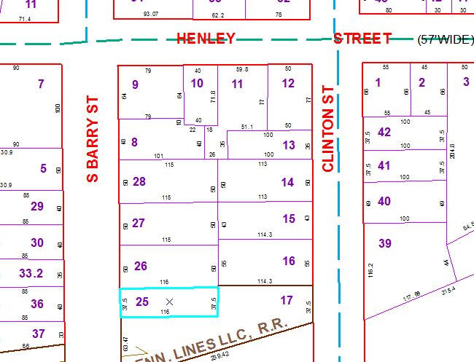

Approximate Yearly Taxes

School $1,486

City $837

County $791

Total $3,114

|  |  |  |  |
| --- | --- | --- | --- |
|  |  |  |  |
|  |  |  |  |
|  |  |  |  |

Special Districts for 2015