Parcel 6

1602 River St, City of Olean

|  |  |  |  |
| --- | --- | --- | --- |
| *No Photo Available* | | **Status:** | Re-Activated |
| **Roll Section:** | Taxable |
| **Swis:** | 041200 |
| **Tax Map ID #:** | 94.033-1-3 |
| **Account #:** | 043860 |
| **Property Class:** | 311 - Res vac land |
| **Site:** | RES 1 |
| **In Ag. District:** | No |
| **Site Property Class:** | 311 - Res vac land |
| **Zoning Code:** | - |
| **Neighborhood Code:** | 12205 |
| **Total Acreage/Size:** | 31.5 x 64 | **School District:** | Olean |
| **Land Assessment:** | 2016- $2,100 | **Total Assessment:** | 2016 - $2,100 |
| **Full Market Value:** | 2016 - $2,283 |  |  |
|  |  |  |  |
|  |  |  |  |
|  |  |  |  |

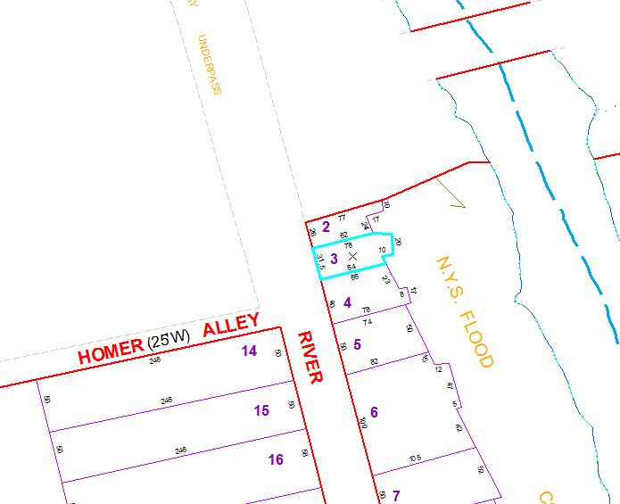

Approximate Yearly Taxes

School $54

City $30

County $29

Total $113

Special Districts for 2015