Parcel 50

122 Henley St E, City of Olean

|  |  |  |  |  |  |  |  |  |  |  |  |  |  |  |  |  |  |
| --- | --- | --- | --- | --- | --- | --- | --- | --- | --- | --- | --- | --- | --- | --- | --- | --- | --- |
| http://maps.cattco.org/Imate/quickstream.aspx?file=VOLLOCAL/Rel2016/041200094073000400600000000005.jpg&thumb=true&width=201&height=152 | | | | | | | | | | **Status:** | | | | Active | | | |
| **Roll Section:** | | | | Taxable | | | |
| **Swis:** | | | | 041200 | | | |
| **Tax Map ID #:** | | | | 94.073-4-6 | | | |
| **Account #:** | | | | 024215 | | | |
| **Property Class:** | | | | 411 - Apartment | | | |
| **Site:** | | | | COM 1 | | | |
| **In Ag. District:** | | | | No | | | |
| **Site Property Class:** | | | | 411 - Apartment | | | |
| **Zoning Code:** | | | | - | | | |
| **Neighborhood Code:** | | | | 12402 | | | |
| **Total Acreage/Size:** | | | | | 40.9 x 100 | | | | | **School District:** | | | | Olean | | | |
| **Land Assessment:** | | | | | 2016 - $4,500 | | | | | **Total Assessment:** | | | | 2016 - $61,000 | | | |
| **Full Market Value:** | | | | | 2016 - $66,304 | | | | |  | | | |  | | | |
| **AC%** | **Sprinkler%** | **Alarm%** | | **Elevators** | | | **Basement Type** | **Year Built** | | | **Condition** | **Quality** | | | **Gross Floor Area (sqft)** | | **Stories** | |
| 0 | 0 | 0 | | 0 | | | Unfinished | 1910 | | | Normal | Average | | | 2660 | | 2.00 | |
| **Structure** | | | **Size** | | | **Grade** | | | **Condition** | | | | **Year** | | |  | | |
| Porch-up covered | | | 25 × 8 | | | Average | | | Normal | | | | 1910 | | |  | | |
| Porch-covered | | | 25 × 8 | | | Average | | | Normal | | | | 1910 | | |  | | |
| Porch-enclosed | | | 25 × 8 | | | Average | | | Normal | | | | 1910 | | |  | | |
| Porch-up enclosed | | | 25 × 8 | | | Average | | | Normal | | | | 1910 | | |  | | |

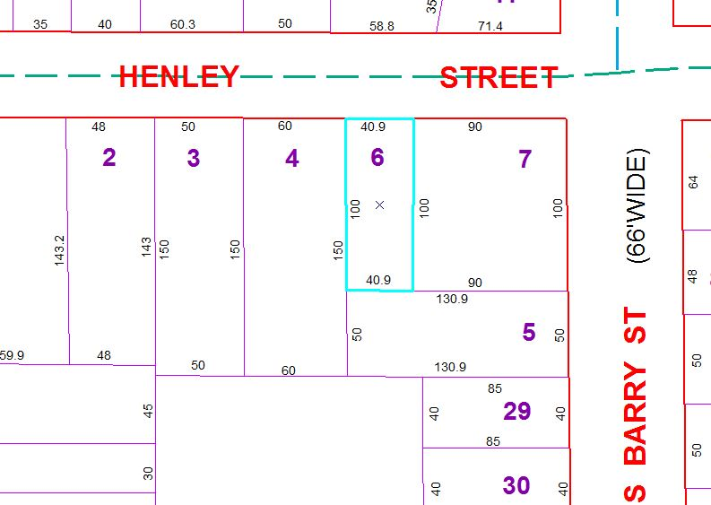

Approximate Yearly Taxes

School $1,563

City $880

County $833

Total $3,276