Parcel 374

9 Borden St, Town of Randolph

|  |  |  |  |  |  |  |  |  |  |  |  |
| --- | --- | --- | --- | --- | --- | --- | --- | --- | --- | --- | --- |
| http://maps.cattco.org/Imate/quickstream.aspx?file=VOLLOCAL/Rel2016/047600070063000301100000000006.jpg&thumb=true&width=201&height=152 | | | | | | **Status:** | | | Active | | |
| **Roll Section:** | | | Taxable | | |
| **Swis:** | | | 047600 | | |
| **Tax Map ID #:** | | | 70.063-3-11 | | |
| **Account #:** | | | 0815 | | |
| **Property Class:** | | | 210 - 1 Family Res | | |
| **Site:** | | | RES 1 | | |
| **In Ag. District:** | | | No | | |
| **Site Property Class:** | | | 210 - 1 Family Res | | |
| **Zoning Code:** | | | R-1 | | |
| **Neighborhood Code:** | | | 76010 | | |
| **Total Acreage/Size:** | | 48 x 107 | | | | **School District:** | | | Randolph | | |
| **Land Assessment:** | | 2016 - $3,300 | | | | **Total Assessment:** | | | 2016 - $43,000 | | |
| **Full Market Value:** | | 2016 - $53,086 | | | |  | | |  | | |
| **Living Area:** | 1,374 sq. ft. | | | **First Story Area:** | | | 694 sq. ft. | | | |
| **Second Story Area:** | 586 sq. ft. | | | **Half Story Area:** | | | 94 sq. ft. | | | |
| **Finished Basement:** | 0 sq. ft. | | | **Number of Stories:** | | | 2 | | | |
| **Building Style:** | Old style | | | **Bathrooms Full - Half:** | | | 1 - 0 | | | |
| **Bedrooms:** | 3 | | | **Kitchens:** | | | 1 | | | |
| **Fireplaces:** | 0 | | | **Basement Type:** | | | Partial | | | |
| **Porch Type:** | Porch-enclosed | | | **Porch Area:** | | | 98.00 | | | |
| **Overall Condition:** | Normal | | | **Overall Grade:** | | | Average | | | |
| **Year Built:** | 1940 | | |  | | |  | | | |
| **Structure** | **Size** | | **Grade** | | **Condition** | | | **Year** | |  | | |
| Porch-enclosed | 7 × 14 | | Average | | Normal | | | 1930 | |  | | |
| Porch-enclosed | 9 × 9 | | Average | | Normal | | | 1930 | |  | | |
| Porch-covered | 66 sq. ft. | | Average | | Normal | | | 1940 | |  | | |

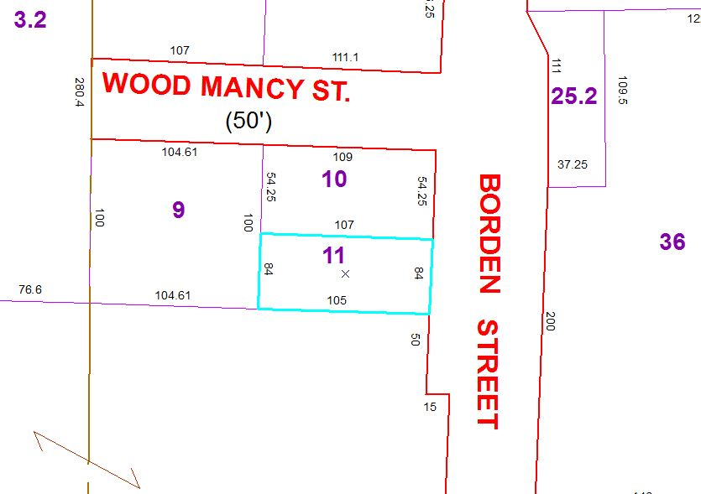

Approximate Yearly Taxes

School $ 572

Town/County $1,196

Total $1,768