Parcel 331

35 Commercial St, V. Gowanda

|  |  |  |  |  |  |  |  |  |  |  |  |  |
| --- | --- | --- | --- | --- | --- | --- | --- | --- | --- | --- | --- | --- |
| http://maps.cattco.org/Imate/quickstream.aspx?file=VOLLOCAL/Rel2016/047201016028000101500000000002.jpg&thumb=true&width=201&height=152 | | | | | | **Status:** | | | | Active | | |
| **Roll Section:** | | | | Taxable | | |
| **Swis:** | | | | 047201 | | |
| **Tax Map ID #:** | | | | 16.028-1-15 | | |
| **Account #:** | | | | 0282 | | |
| **Property Class:** | | | | 220 - 2 Family Res | | |
| **Site:** | | | | RES 1 | | |
| **In Ag. District:** | | | | No | | |
| **Site Property Class:** | | | | 220 - 2 Family Res | | |
| **Zoning Code:** | | | | - | | |
| **Neighborhood Code:** | | | | 72080 | | |
| **Total Acreage/Size:** | | | 37 x 176 | | | **School District:** | | | | Gowanda | | |
| **Land Assessment:** | | | 2016 - $3,500 | | | **Total Assessment:** | | | | 2016 - $40,500 | | |
| **Full Market Value:** | | | 2016 - $52,597 | | |  | | | |  | | |
| **Living Area:** | | 2,094 sq. ft. | | | **First Story Area:** | | | 1,047 sq. ft. | | | |
| **Second Story Area:** | | 1,047 sq. ft. | | | **Half Story Area:** | | | 0 sq. ft. | | | |
| **Finished Basement:** | | 0 sq. ft. | | | **Number of Stories:** | | | 2 | | | |
| **Building Style:** | | Old style | | | **Bathrooms Full - Half:** | | | 2 - 0 | | | |
| **Bedrooms:** | | 6 | | | **Kitchens:** | | | 2 | | | |
| **Fireplaces:** | | 0 | | | **Basement Type:** | | | Full | | | |
| **Porch Type:** | | Porch-covered | | | **Porch Area:** | | | 132.00 | | | |
| **Overall Condition:** | | Fair | | | **Overall Grade:** | | | Average | | | |
| **Year Built:** | | 1900 | | |  | | |  | | | |
| **Structure** | **Size** | | | **Grade** | | | **Condition** | | **Year** | |  | | |
| Porch-covered | 11 × 12 | | | Average | | | Fair | | 1900 | |  | | |
| Gar-1.0 detached | 22 × 22 | | | Average | | | Fair | | 1920 | |  | | |
| Gar-1.0 detached | 20 × 20 | | | Average | | | Fair | | 1920 | |  | | |
| Porch-covered | 288 sq. ft. | | | Average | | | Fair | | 1900 | |  | | |
| Porch-enclosed | 0 x 0 | | | Average | | | Normal | | 1900 | |  | | |

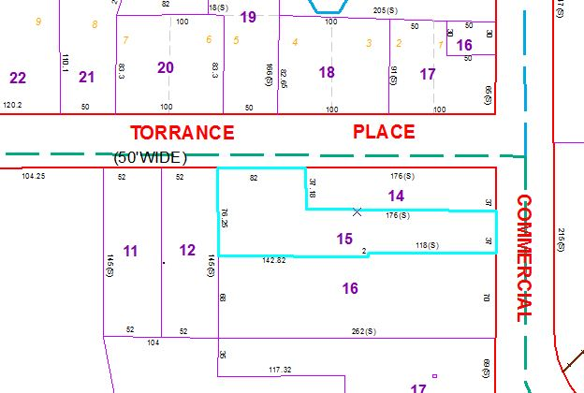

Approximate Yearly Taxes

School $ 960

Village $ 676

Town/County $ 846

Total $2,482

|  |  |  |  |
| --- | --- | --- | --- |
|  |  |  |  |