Parcel 326

11014 North Rd, Town of Perrysburg

|  |  |  |  |  |  |  |  |  |
| --- | --- | --- | --- | --- | --- | --- | --- | --- |
|  | | | **Status:** | | Active | | | |
| **Roll Section:** | | Taxable | | | |
| **Swis:** | | 047000 | | | |
| **Tax Map ID #:** | | 8.001-1-15.2 | | | |
| **Account #:** | | 0833 | | | |
| **Property Class:** | | 210 - 1 Family Res | | | |
| **Site:** | | RES 1 | | | |
| **In Ag. District:** | | No | | | |
| **Site Property Class:** | | 210 - 1 Family Res | | | |
| **Zoning Code:** | | AR40 | | | |
| **Neighborhood Code:** | | 70350 | | | |
| **Total Acreage/Size:** | 5.50 | | **School District:** | | Gowanda | | | |
| **Land Assessment:** | 2016 - $11,500 | | **Total Assessment:** | | 2016 - $38,600 | | | |
| **Full Market Value:** | 2016 - $54,366 | |  | |  | | |
| **Living Area:** | 1,377 sq. ft. | | **First Story Area:** | | 918 sq. ft. | | |
| **Second Story Area:** | 0 sq. ft. | | **Half Story Area:** | | 459 sq. ft. | | |
| **Finished Basement:** | 0 sq. ft. | | **Number of Stories:** | | 1.5 | | |
| **Building Style:** | Old style | | **Bathrooms Full – Half:** | | 1 - 0 | | |
| **Bedrooms:** | 3 | | **Kitchens:** | | 1 | | |
| **Fireplaces:** | 0 | | **Basement Type:** | | Full | | |
| **Porch Type:** | Porch-covered | | **Porch Area:** | | 24.00 | | |
| **Overall Condition:** | Normal | | **Overall Grade:** | | Average | | |
| **Year Built:** | 1850 | |  | |  | | |
| **Structure** | **Size** | **Grade** | | **Condition** | | **Year** |  | | |
| Gar-1.0 detached | 14 × 24 | Average | | Normal | | 1980 |  | | |
| Porch-covered | 4 × 6 | Average | | Normal | | 1960 |  | | |
| Porch-enclosed | 5 × 7 | Average | | Normal | | 1990 |  | | |

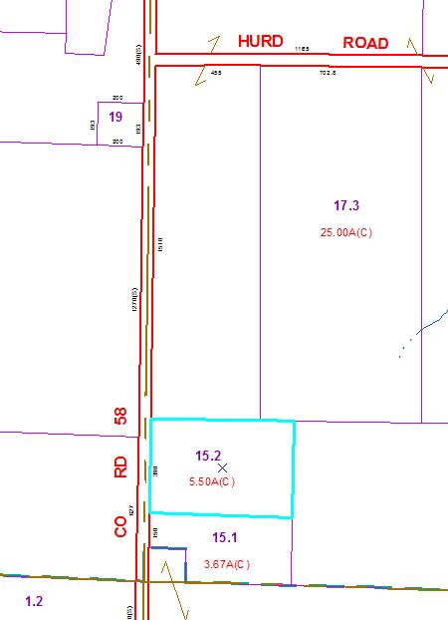

Approximate Yearly Taxes

School $ 993

Town/County $1,055

Total $2,048