Parcel 325

11008 North Rd, Town of Perrysburg

|  |  |  |  |  |  |  |  |  |
| --- | --- | --- | --- | --- | --- | --- | --- | --- |
| *No Photo Available* | | | **Status:** | | Active | | | |
| **Roll Section:** | | Taxable | | | |
| **Swis:** | | 047000 | | | |
| **Tax Map ID #:** | | 8.001-1-15.1 | | | |
| **Account #:** | | 0409 | | | |
| **Property Class:** | | 312 - Vac w/imprv | | | |
| **Site:** | | RES 1 | | | |
| **In Ag. District:** | | No | | | |
| **Site Property Class:** | | 312 - Vac w/imprv | | | |
| **Zoning Code:** | | AR20 | | | |
| **Neighborhood Code:** | | 70350 | | | |
| **Total Acreage/Size:** | 3.67 | | **School District:** | | Gowanda | | | |
| **Land Assessment:** | 2016 - $9,000 | | **Total Assessment:** | | 2016 - $14,700 | | | |
| **Full Market Value:** | 2016 - $20,704 | |  | |  | | |
| **Structure** | **Size** | **Grade** | | **Condition** | | **Year** |  | | |
| Gar-1.0 detached | 18 × 24 | Average | | Normal | | 1988 |  | | |

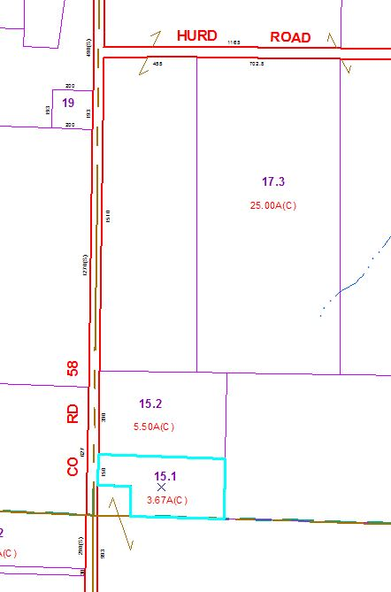

Approximate Yearly Taxes

School $378

Town/County $402

Total $780