Parcel 295

74 South St, V. Cattaraugus

|  |  |  |  |  |  |  |  |  |  |  |  |  |  |  |  |
| --- | --- | --- | --- | --- | --- | --- | --- | --- | --- | --- | --- | --- | --- | --- | --- |
| http://maps.cattco.org/Imate/quickstream.aspx?file=VOLLOCAL/Rel2016/046401035082000501600000000002.jpg&thumb=true&width=201&height=152 | | | | | | | **Status:** | | | | Active | | | | |
| **Roll Section:** | | | | Taxable | | | | |
| **Swis:** | | | | 046401 | | | | |
| **Tax Map ID #:** | | | | 35.082-5-16 | | | | |
| **Account #:** | | | | 0585 | | | | |
| **Property Class:** | | | | 210 - 1 Family Res | | | | |
| **Site:** | | | | RES 1 | | | | |
| **In Ag. District:** | | | | No | | | | |
| **Site Property Class:** | | | | 210 - 1 Family Res | | | | |
| **Zoning Code:** | | | | - | | | | |
| **Neighborhood Code:** | | | | 00000 | | | | |
| **Total Acreage/Size:** | | | 66 x 90.75 | | | | **School District:** | | | | Cattaraugus - Little Valley | | | | |
| **Land Assessment:** | | | 2016 - $1,900 | | | | **Total Assessment:** | | | | 2016 - $30,000 | | | | |
| **Full Market Value:** | | | 2016 - $42,254 | | | |  | | | |  | | |
| **Living Area:** | | 2,160 sq. ft. | | | **First Story Area:** | | | | | 1,080 sq. ft. | | |
| **Second Story Area:** | | 1,080 sq. ft. | | | **Number of Stories:** | | | | | 2 | | |
| **Building Style:** | | Old style | | | **Bathrooms Full - Half:** | | | | | 1 - 0 | | |
| **Bedrooms:** | | 4 | | | **Kitchens:** | | | | | 1 | | |
| **Fireplaces:** | | 0 | | | **Basement Type:** | | | | | Partial | | |
| **Porch Type:** | | Porch-covered | | | **Porch Area:** | | | | | 192.00 | | |
| **Overall Condition:** | | Fair | | | **Overall Grade:** | | | | | Average | | |
| **Year Built:** | | 1910 | | |  | | |  | | | | |
| **Structure** | | **Size** | | | **Grade** | | | **Condition** | | | | |
| Porch-covered | 8 × 24 | | | Average | | Fair | | | **Year** | | |  | | |
| Porch-covered | 8 × 18 | | | Average | | Fair | | | 1910 | | |  | | |
|  |  | | |  | |  | | |  | | |  | | |

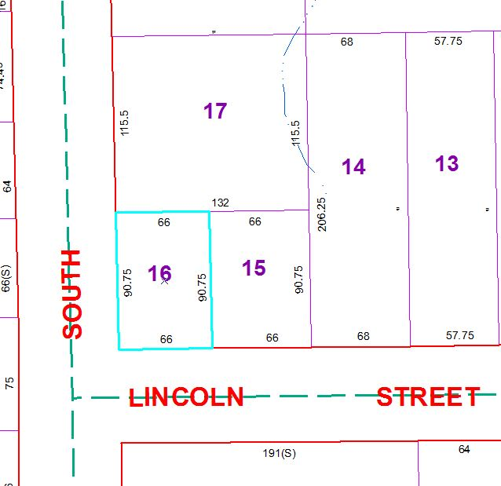

Approximate Yearly Taxes

School $ 643

Village $ 583

Town/County $ 782

Total $2,008