Parcel 290

135 Waverly St, V. Cattaraugus

|  |  |  |  |  |  |  |  |  |  |
| --- | --- | --- | --- | --- | --- | --- | --- | --- | --- |
| *No Photo Available* | | | | **Status:** | | Active | | | |
| **Roll Section:** | | Taxable | | | |
| **Swis:** | | 046401 | | | |
| **Tax Map ID #:** | | 35.082-3-13 | | | |
| **Account #:** | | 0858 | | | |
| **Property Class:** | | 311 - Res vac land | | | |
| **Site:** | | RES 1 | | | |
| **In Ag. District:** | | No | | | |
| **Site Property Class:** | | 311 - Res vac land | | | |
| **Zoning Code:** | | - | | | |
| **Neighborhood Code:** | | 00000 | | | |
| **Total Acreage/Size:** | | 57 x 180.3 | | **School District:** | | Cattaraugus - Little Valley | | | |
| **Land Assessment:** | | 2016 - $2,200 | | **Total Assessment:** | | 2016 - $2,200 | | | |
| **Full Market Value:** | | 2016 - $3,099 | |  | |  | | |
|  |  | |  | |  | |  |  | | |
|  |  | |  | |  | |  |  | | |

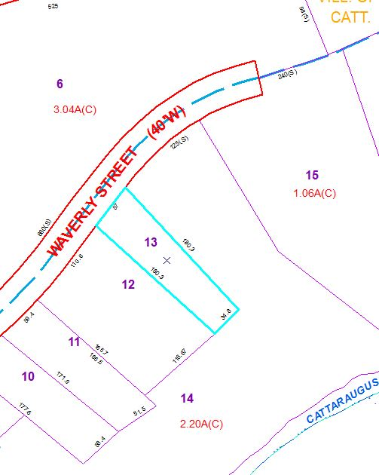

Approximate Yearly Taxes

School $ 48

Village $ 43

Town/County $ 58

Total $149