Parcel 286

9339 Pigeon Valley Rd, Town of New Albion

|  |  |  |  |  |  |  |  |  |  |
| --- | --- | --- | --- | --- | --- | --- | --- | --- | --- |
| http://maps.cattco.org/Imate/quickstream.aspx?file=VOLLOCAL/Rel2016/046489053002000202400200000005.jpg&thumb=true&width=201&height=152 | | | | | **Status:** | | Active | | |
| **Roll Section:** | | Taxable | | |
| **Swis:** | | 046489 | | |
| **Tax Map ID #:** | | 53.002-2-24.2 | | |
| **Account #:** | | 1082 | | |
| **Property Class:** | | 270 - Mfg housing | | |
| **Site:** | | RES 1 | | |
| **In Ag. District:** | | No | | |
| **Site Property Class:** | | 270 - Mfg housing | | |
| **Zoning Code:** | | - | | |
| **Neighborhood Code:** | | 64350 | | |
| **Total Acreage/Size:** | | 180 x 254 | | | **School District:** | | Cattaraugus - Little Valley | | |
| **Land Assessment:** | | 2016 - $4,600 | | | **Total Assessment:** | | 2016 - $56,000 | | |
| **Full Market Value:** | | 2016 - $78,873 | | |  | |  | |
| **Structure** | **Size** | | **Grade** | **Condition** | | **Year** | |  | |
| Shed-machine | 22 × 12 | | Average | Normal | | 1972 | |  | |
| Shed-machine | 12 × 12 | | Average | Normal | | 1972 | |  | |
| Mobile home | 76 × 28 | | Average | Normal | | 2004 | |  | |

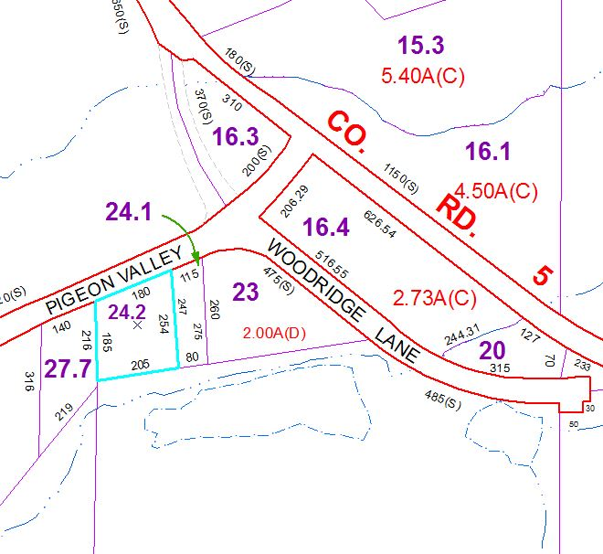

Approximate Yearly Taxes

School $1,199

Town/County $1,651

Total $2,850