Parcel 285

35 Main St N, V. Cattaraugus

|  |  |  |  |  |  |  |  |  |  |  |  |  |  |  |
| --- | --- | --- | --- | --- | --- | --- | --- | --- | --- | --- | --- | --- | --- | --- |
| http://maps.cattco.org/Imate/quickstream.aspx?file=VOLLOCAL/Rel2016/046401035081000101300000000010.jpg&thumb=true&width=201&height=152 | | | | | | **Status:** | | | | Active | | | | |
| **Roll Section:** | | | | Taxable | | | | |
| **Swis:** | | | | 046401 | | | | |
| **Tax Map ID #:** | | | | 35.081-1-13 | | | | |
| **Account #:** | | | | 0646 | | | | |
| **Property Class:** | | | | 210 - 1 Family Res | | | | |
| **Site:** | | | | RES 1 | | | | |
| **In Ag. District:** | | | | No | | | | |
| **Site Property Class:** | | | | 210 - 1 Family Res | | | | |
| **Zoning Code:** | | | | - | | | | |
| **Total Acreage/Size:** | | 1.30 | | | | **School District:** | | | | Cattaraugus - Little Valley | | | | |
| **Land Assessment:** | | 2016 - $8,200 | | | | **Total Assessment:** | | | | 2016 - $25,000 | | | | |
| **Full Market Value:** | | 2016 - $35,211 | | | |  | | | |  | | |
| **Living Area:** | 1,516 sq. ft. | | | **First Story Area:** | | | | | 928 sq. ft. | | |
| **Second Story Area:** | 588 sq. ft. | | | **Half Story Area:** | | | | | 0 sq. ft. | | |
| **Finished Basement:** | 0 sq. ft. | | | **Number of Stories:** | | | | | 2 | | |
| **Building Style:** | Old style | | | **Bathrooms (Full - Half):** | | | | | 1 - 1 | | |
| **Bedrooms:** | 3 | | | **Kitchens:** | | | | | 1 | | |
| **Fireplaces:** | 0 | | | **Basement Type:** | | | | | Partial | | |
| **Porch Type:** | Porch-enclosed | | | **Porch Area:** | | | | | 160.00 | | |
| **Overall Condition:** | Fair | | | **Overall Grade:** | | | | | Average | | |
| **Year Built:** | 1900 | | |  | | |  | | | | |
| **Structure** | **Size** | | **Grade** | | **Condition** | | | **Year** | | |  | | |
| Porch-enclosed | 8 × 20 | | Average | | Normal | | | 1900 | | |  | | |
| Porch-open/deck | 24 × 10 | | Average | | Normal | | | 1900 | | |  | | |

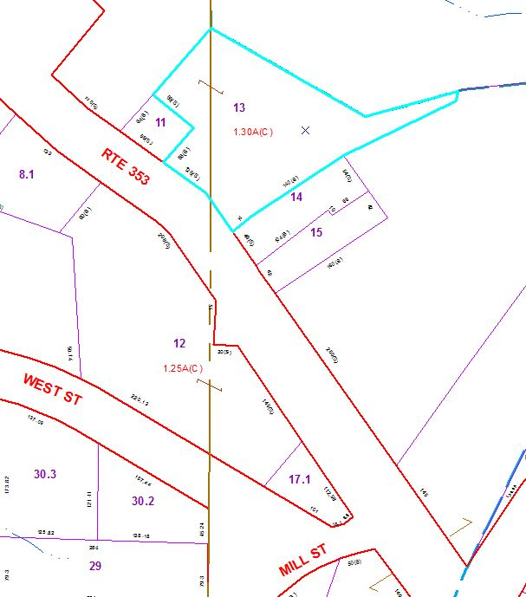

Approximate Yearly Taxes

School $ 535

Village $ 487

Town/County $ 652

Total $1,674