Parcel 280

10 Summervale Dr., Town of Napoli

|  |  |  |  |  |  |  |  |  |  |
| --- | --- | --- | --- | --- | --- | --- | --- | --- | --- |
| http://maps.cattco.org/Imate/quickstream.aspx?file=VOLLOCAL/Rel2015/046200062039000101100000000003.jpg&thumb=true&width=201&height=152 | | | | **Status:** | | Active | | | |
| **Roll Section:** | | Taxable | | | |
| **Swis:** | | 046200 | | | |
| **Tax Map ID #:** | | 62.039-1-11 | | | |
| **Account #:** | | 0965 | | | |
| **Property Class:** | | 312 - Vac w/imprv. | | | |
| **Site:** | | RES 1 | | | |
| **In Ag. District:** | | No | | | |
| **Site Property Class:** | | 312 - Vac w/imprv. | | | |
| **Zoning Code:** | | - | | | |
| **Neighborhood Code:** | | 62030 | | | |
| **Total Acreage/Size:** | | 75 x 150 | | **School District:** | | Cattaraugus - Little Valley | | | |
| **Land Assessment:** | | 2016 - $800 | | **Total Assessment:** | | 2016 - $4,000 | | | |
| **Full Market Value:** | | 2016 - $4,000 | |  | |  | | |
| **Structure** | **Size** | | **Grade** | | **Condition** | | **Year** |  | | |
| Shed-machine | 15 × 15 | | Average | | Normal | | 1990 |  | | |

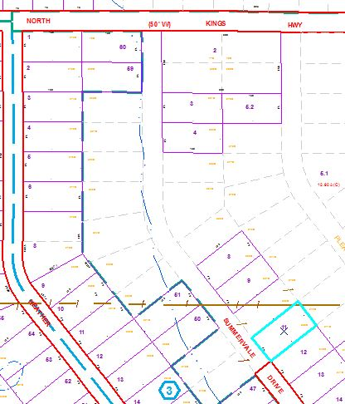

Approximate Yearly Taxes

School $ 62

Town/County $ 81

Total $143