Parcel 259

Middle Rd, Town of Machias

|  |  |  |  |
| --- | --- | --- | --- |
| *No Photo Available* | | **Status:** | Active |
| **Roll Section:** | Taxable |
| **Swis:** | 045800 |
| **Tax Map ID #:** | 22.013-3-35 |
| **Account #:** | 0464 |
| **Property Class:** | 311 - Res vac land |
| **Site:** | RES 1 |
| **In Ag. District:** | No |
| **Site Property Class:** | 311 - Res vac land |
| **Zoning Code:** | 01 |
| **Neighborhood Code:** | 58050 |
| **Total Acreage/Size:** | 100 x 75 | **School District:** | Yorkshire-Pioneer |
| **Land Assessment:** | 2016 - $4,200 | **Total Assessment:** | 2016 - $4,200 |
| **Full Market Value:** | 2016 - $4,200 |  |  |
|  |  |  |  |

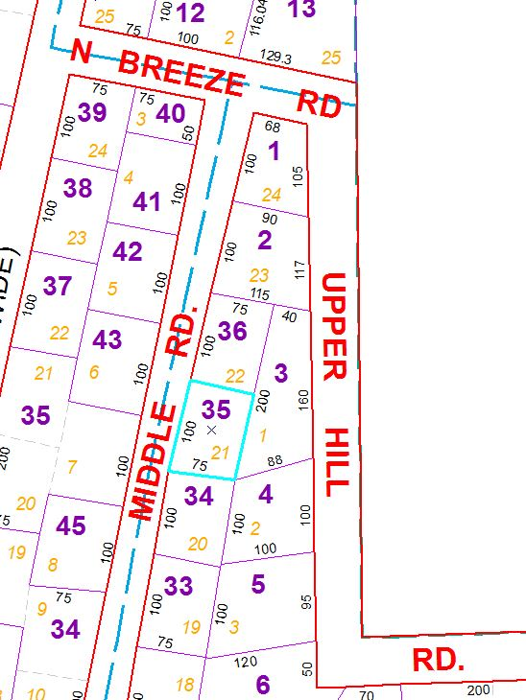

Approximate Yearly Taxes

School $60

Town/County $81

Total $141