Parcel 252
9732 McKinstry Rd, Town of Machias
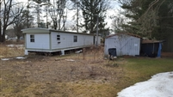 |  | Status: | Active
 |  | Roll Section: | Taxable
 |  | Swis: | 045800
 |  | Tax Map ID #: | 21.020-1-23
 |  | Account #: | 1185
 |  | Property Class: | 270 - Mfg housing
 |  | Site: | RES 1
 |  | In Ag. District: | No
 |  | Site Property Class: | 270 - Mfg housing
 |  | Zoning Code: | 01
 |  | Neighborhood Code: | 58080
Total Acreage/Size: | 97.5 x 225 | School District: | Yorkshire-Pioneer
Land Assessment: | 2016 - $9,300 | Total Assessment: | 2016 - $49,100
Full Market Value: | 2016 - $49,100

Structure | Size | Grade | Condition | Year
Shed-machine | 12 × 12 | Economy | Normal | 1980
Mobile home | 70 × 14 | Average | Normal | 1980

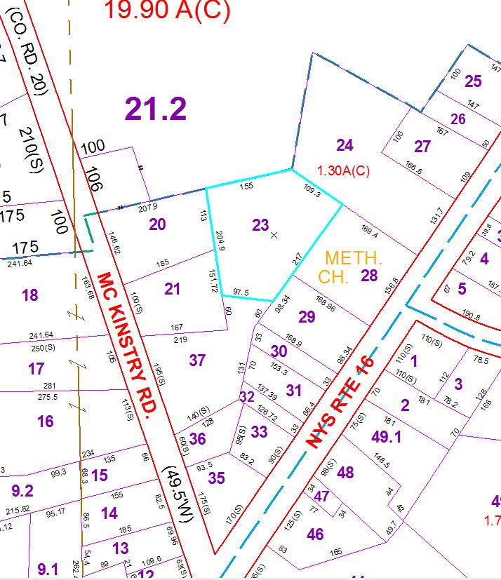 | Approximate Yearly Taxes  School $656  Town/County $904  Total 1560

