Parcel 21

1202 Sullivan St W, City of Olean

|  |  |  |  |  |  |  |  |  |  |  |  |  |  |  |  |  |
| --- | --- | --- | --- | --- | --- | --- | --- | --- | --- | --- | --- | --- | --- | --- | --- | --- |
| http://maps.cattco.org/Imate/quickstream.aspx?file=VOLLOCAL/Rel2016/041200094056000304500000000007.jpg&thumb=true&width=201&height=152 | | | | | | | | **Status:** | | | | Active | | | | |
| **Roll Section:** | | | | Taxable | | | | |
| **Swis:** | | | | 041200 | | | | |
| **Tax Map ID #:** | | | | 94.056-3-45 | | | | |
| **Account #:** | | | | 054300 | | | | |
| **Property Class:** | | | | 411 - Apartment | | | | |
| **Site:** | | | | COM 1 | | | | |
| **In Ag. District:** | | | | No | | | | |
| **Site Property Class:** | | | | 411 - Apartment | | | | |
| **Zoning Code:** | | | | - | | | | |
| **Neighborhood Code:** | | | | 12402 | | | | |
| **Total Acreage/Size:** | | | | 33.3 x 81.5 | | | | **School District:** | | | | Olean | | | | |
| **Land Assessment:** | | | | 201 - $5,300 | | | | **Total Assessment:** | | | | 2016 - $64,000 | | | | |
| **Full Market Value:** | | | | 2016 - $69,565 | | | |  | | | |  | | | | |
| **AC%** | **Sprinkler%** | **Alarm%** | | | **Elevators** | | **Basement Type** | | **Year Built** | | **Condition** | | **Quality** | | **Gross Floor Area (sq ft)** | | | **Stories** |
| 0 | 0 | 0 | | | 0 | | Unfinished | | 1906 | | Normal | | Average | | 2511 | | | 2.00 |
| **Structure** | | | **Size** | | | **Grade** | | | | **Condition** | | | | **Year** | |  | | |
| Porch-up enclosed | | | 24 × 8 | | | Average | | | | Normal | | | | 1906 | |  | | |
| Porch-enclosed | | | 24 × 6 | | | Average | | | | Normal | | | | 1906 | |  | | |
| Porch-up open | | | 24 × 8 | | | Average | | | | Good | | | | 2010 | |  | | |
| Porch-covered | | | 24 × 8 | | | Average | | | | Good | | | | 2010 | |  | | |

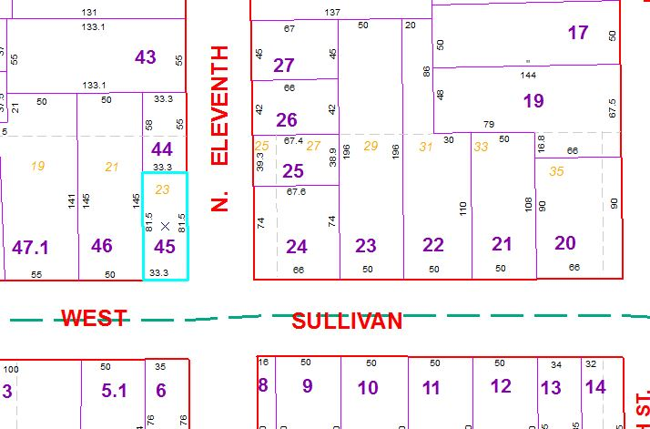

Approximate Yearly Taxes

School $1,640

City $923

County $873

Total $3,436

|  |  |  |  |  |  |
| --- | --- | --- | --- | --- | --- |
|  |  |  |  |  |  |