Parcel 2

137-39 Fulton St, City of Olean

|  |  |  |  |  |  |  |  |  |  |  |  |  |  |  |
| --- | --- | --- | --- | --- | --- | --- | --- | --- | --- | --- | --- | --- | --- | --- |
| http://maps.cattco.org/Imate/quickstream.aspx?file=VOLLOCAL/Rel2016/041200094065000601000000000008.jpg&thumb=true&width=201&height=152 | | | | | | | **Status:** | | | | Active | | | |
| **Roll Section:** | | | | Taxable | | | |
| **Swis:** | | | | 041200 | | | |
| **Tax Map ID #:** | | | | 94.065-6-10 | | | |
| **Account #:** | | | | 018835 | | | |
| **Property Class:** | | | | 210 - 1 Family Res | | | |
| **Site:** | | | | RES 1 | | | |
| **In Ag. District:** | | | | No | | | |
| **Site Property Class:** | | | | 210 - 1 Family Res | | | |
| **Zoning Code:** | | | | - | | | |
| **Neighborhood Code:** | | | | 12203 | | | |
| **Total Acreage/Size:** | | | 105 x 158.5 | | | | **School District:** | | | | Olean | | | |
| **Land Assessment:** | | | 2016 - $7,200 | | | | **Total Assessment:** | | | | 2016 - $129,000 | | | |
| **Full Market Value:** | | | 2016 - $140,217 | | | |  | | | |  | | |
| **Living Area:** | | 4,368 sq. ft. | | | **First Story Area:** | | | | | 2,234 sq. ft. | | |
| **Second Story Area:** | | 2,134 sq. ft. | | | **Half Story Area:** | | | | | 0 sq. ft. | | |
| **Finished Basement:** | | 0 sq. ft. | | | **Number of Stories:** | | | | | 2 | | |
| **Building Style:** | | Old style | | | **Bathrooms (Full - Half):** | | | | | 2 - 1 | | |
| **Bedrooms:** | | 4 | | | **Kitchens:** | | | | | 1 | | |
| **Fireplaces:** | | 8 | | | **Basement Type:** | | | | | Full | | |
| **Porch Type:** | | Porch-covered | | | **Porch Area:** | | | | | 80.00 | | |
| **Overall Condition:** | | Normal | | | **Overall Grade:** | | | | | Good | | |
| **Year Built:** | | 1905 | | |  | | | |  | | | |
| **Structure** | **Size** | | | **Grade** | | **Condition** | | **Year** | | | |  | |
| Porch-covered | 16 × 5 | | | Average | | Normal | | 1905  Approximate Yearly Taxes  School $3,305  City $1,760  County $1,861  Total $6,926 | | | |  | |
| Gar-2.0 det. | 24 × 36 | | | Average | | Normal | | 1905 | | | |  | |
| Porch-covered | 308 sq. ft. | | | Average | | Good | | 1905 | | | |  | |
| Porch-open/deck | 208 sq. ft. | | | Good | | Good | | 1985 | | | |  | |

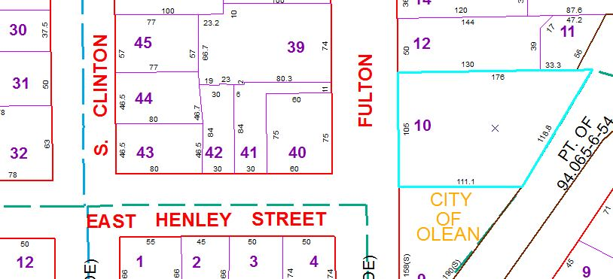

Special Districts for 2015