Parcel 199

Hedden Hollow Rd, Town of Hinsdale

|  |  |  |  |  |  |
| --- | --- | --- | --- | --- | --- |
| *No Photo Available* | | **Status:** | Active | | |
| **Roll Section:** | Taxable | | |
| **Swis:** | 044600 | | |
| **Tax Map ID #:** | 77.004-3-13.1 | | |
| **Account #:** | 0969 | | |
| **Property Class:** | 314 - Rural vac<10 | | |
| **Site:** | RES 1 | | |
| **In Ag. District:** | No | | |
| **Site Property Class:** | 314 - Rural vac<10 | | |
| **Zoning Code:** | - | | |
| **Neighborhood Code:** | 46100 - Town Roads | | |
| **Total Acreage/Size:** | 1.16 | **School District:** | Hinsdale | | |
| **Land Assessment:** | 2016 - $8,100 | **Total Assessment:** | 2016 - $8,100 | | |
| **Full Market Value:** | 2016 - $9,205 |  |  | | |
|  |  |  |  |  |

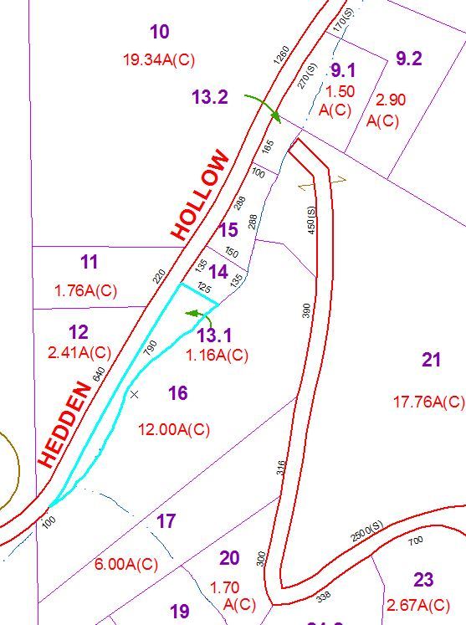

Approximate Yearly Taxes

School $138

Town/County $190

Total $328