Parcel 187

11486 Rte 98, Town of Freedom

|  |  |  |  |  |  |  |  |  |  |
| --- | --- | --- | --- | --- | --- | --- | --- | --- | --- |
|  | | | | **Status:** | | Active | | | |
| **Roll Section:** | | Taxable | | | |
| **Swis:** | | 044200 | | | |
| **Tax Map ID #:** | | 14.005-1-29 | | | |
| **Account #:** | | 0549 | | | |
| **Property Class:** | | 210 - 1 Family Res | | | |
| **Site:** | | RES 1 | | | |
| **In Ag. District:** | | No | | | |
| **Site Property Class:** | | 210 - 1 Family Res | | | |
| **Zoning Code:** | | 01 | | | |
| **Neighborhood Code:** | | 04200 - Freedom | | | |
| **Total Acreage/Size:** | | 9.19 | | **School District:** | | Yorkshire-Pioneer | | | |
| **Land Assessment:** | | 2016 - $20,300 | | **Total Assessment:** | | 2016 - $79,500 | | | |
| **Full Market Value:** | | 2016 - $79,500 | |  | |  | | |
| **Living Area:** | | 1,938 sq. ft. | | **First Story Area:** | | 1,292 sq. ft. | | |
| **Second Story Area:** | | 0 sq. ft. | | **Half Story Area:** | | 646 sq. ft. | | |
| **Finished Basement:** | | 0 sq. ft. | | **Number of Stories:** | | 1.5 | | |
| **Building Style:** | | Old style | | **Bathrooms Full** | | 1 | | |
| **Bedrooms:** | | 3 | | **Kitchens:** | | 1 | | |
| **Fireplaces:** | | 0 | | **Basement Type:** | | Crawl | | |
| **Porch Type:** | | Porch-enclosed | | **Porch Area:** | | 120.00 | | |
| **Overall Condition:** | | Fair | | **Overall Grade:** | | Economy | | |
| **Year Built:** | | 1900 | |  | |  | | |
| **Structure** | **Size** | | **Grade** | | **Condition** | | **Year** |  | | |
| Shed-machine | 12 × 13 | | Economy | | Fair | | 1920 |  | | |
| Gar-1.0 detached | 19 × 25 | | Minimum | | Fair | | 1920 |  | | |
| Shed-machine | 19 × 26 | | Economy | | Fair | | 1920 |  | | |
| Shed-machine | 12 × 14 | | Economy | | Fair | | 1920 |  | | |
| Shed-machine | 10 x 14 | | Economy | | Fair | | 1920 |  | | |
| Shed-machine | 15 x 38 | | Economy | | Fair | | 1920 |  | | |
| Barn-2.0 gen | 25 x 33 | | Economy | | Fair | | 1920 |  | | |
| Porch-enclosed | 20 x 6 | | Average | | Normal | | 1900 |  | | |

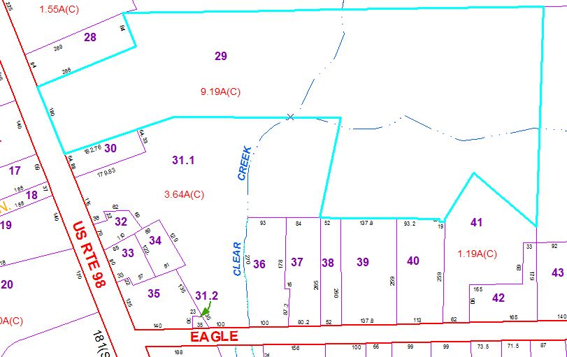

Approximate Yearly Taxes

School $1,108

Town/County $1,427

Total $2,535