Parcel 165

10 Factory St, V. Franklinville

|  |  |  |  |  |  |  |  |
| --- | --- | --- | --- | --- | --- | --- | --- |
| http://maps.cattco.org/Imate/quickstream.aspx?file=VOLLOCAL/Rel2016/044001040070000200600000000002.jpg&thumb=true&width=201&height=152 | | | | **Status:** | | Active | |
| **Roll Section:** | | Taxable | |
| **Swis:** | | 044001 | |
| **Tax Map ID #:** | | 40.070-2-6 | |
| **Account #:** | | 0792 | |
| **Property Class:** | | 210 - 1 Family Res | |
| **Site:** | | RES 1 | |
| **In Ag. District:** | | No | |
| **Site Property Class:** | | 210 - 1 Family Res | |
| **Zoning Code:** | | 1030 | |
| **Neighborhood Code:** | | 40150 | |
| **Total Acreage/Size:** | | 47.36 x 75.77 | | **School District:** | | Franklinville | |
| **Land Assessment:** | | 2016 - $4,000 | | **Total Assessment:** | | 2016 - $7,800 | |
| **Full Market Value:** | | 2016 - $11,143 | |  | |  | |
| **Living Area:** | 837 sq. ft. | | **First Story Area:** | | 837 sq. ft. | |
| **Second Story Area:** | 0 sq. ft. | | **Half Story Area:** | | 418 sq. ft. | |
| **Finished Basement:** | 0 sq. ft. | | **Number of Stories:** | | 1.5 | |
| **Building Style:** | Old style | | **Bathrooms (Full - Half):** | | 1 - 0 | |
| **Bedrooms:** | 2 | | **Kitchens:** | | 1 | |
| **Fireplaces:** | 0 | | **Basement Type:** | | Crawl | |
| **Overall Condition:** | Fair | | **Overall Grade:** | | Economy | |
| **Year Built:** | 1920 | |  | |  | |  | |  |

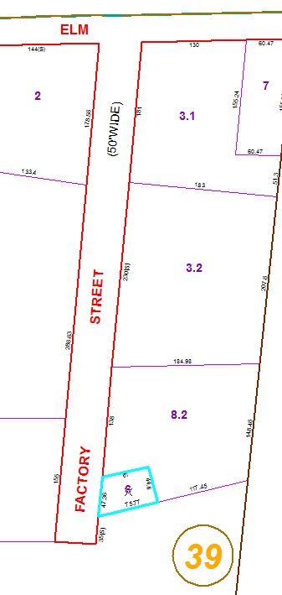

Approximate Yearly Taxes

School $204

Village $102

Town/County $227

Total $533

|  |  |  |  |  |  |
| --- | --- | --- | --- | --- | --- |
|  |  |  |  |  |  |