Parcel 148

6944 Poverty Hill Rd, Town of Ellicottville

|  |  |  |  |  |  |  |  |  |
| --- | --- | --- | --- | --- | --- | --- | --- | --- |
| http://maps.cattco.org/Imate/quickstream.aspx?file=VOLLOCAL/Rel2016/043689046002000103500500000007.jpg&thumb=true&width=201&height=152 | | | | **Status:** | | Active | | |
| **Roll Section:** | | Taxable | | |
| **Swis:** | | 043689 | | |
| **Tax Map ID #:** | | 46.002-1-35.5 | | |
| **Account #:** | | 3016 | | |
| **Property Class:** | | 210 - 1 Family Res | | |
| **Site:** | | RES 1 | | |
| **In Ag. District:** | | No | | |
| **Site Property Class:** | | 210 - 1 Family Res | | |
| **Zoning Code:** | | 07 | | |
| **Neighborhood Code:** | | 36050 - Village/V/o | | |
| **Total Acreage/Size:** | | 4.90 | | **School District:** | | Ellicottville | | |
| **Land Assessment:** | | 2016 - $36,300 | | **Total Assessment:** | | 2016 - $43,700 | | |
| **Full Market Value:** | | 2016 - $43,700 | |  | |  | |
| **Living Area:** | 2,146 sq. ft. | | **First Story Area:** | | 1,474 sq. ft. | |
| **Additional Story Area:** | 0 sq. ft. | | **3/4 Story Area:** | | 672 sq. ft. | |
| **Finished Basement:** | 0 sq. ft. | | **Number of Stories:** | | 1.7 | |
| **Building Style:** | Cottage | | **Bathrooms (Full - Half):** | | 1 - 0 | |
| **Bedrooms:** | 3 | | **Kitchens:** | | 1 | |
| **Fireplaces:** | 1 | | **Basement Type:** | | Slab/pier | |
| **Overall Condition:** | Fair | | **Overall Grade:** | | Minimum | |

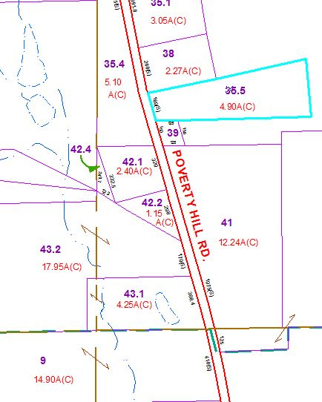

Approximate Yearly Taxes

School $374

Town/County $644

Total $1,018