Parcel 141

Fancy Tract Rd, Town of Ellicottville

|  |  |  |  |  |
| --- | --- | --- | --- | --- |
| *No Photo Available* | | **Status:** | Active | |
| **Roll Section:** | Taxable | |
| **Swis:** | 043689 | |
| **Tax Map ID #:** | 38.004-1-18.3 | |
| **Account #:** | 1444 | |
| **Property Class:** | 314 - Rural vac<10 | |
| **Site:** | RES 1 | |
| **In Ag. District:** | No | |
| **Site Property Class:** | 314 - Rural vac<10 | |
| **Zoning Code:** | 04 | |
| **Neighborhood Code:** | 36030 - West Valley School | |
| **Total Acreage/Size:** | 15 x 160 | **School District:** | West Valley | |
| **Land Assessment:** | 2016 - $1,200 | **Total Assessment:** | 2016 - $1,200 | |
| **Full Market Value:** | 2016 - $1,200 |  |  |
|  |  |  |  |

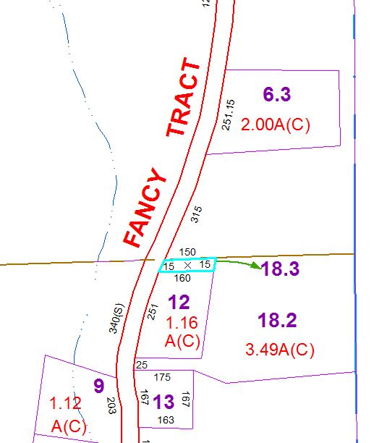

Approximate Yearly Taxes

School $28

Town/County $18

Total $46