Parcel 118

James Rd, Town of Dayton

|  |  |  |  |
| --- | --- | --- | --- |
| *No Photo Available* | | **Status:** | Active |
| **Roll Section:** | Taxable |
| **Swis:** | 043089 |
| **Tax Map ID #:** | 16.004-1-46.3 |
| **Account #:** | 0239 |
| **Property Class:** | 311 - Res vac land |
| **Site:** | RES 1 |
| **In Ag. District:** | No |
| **Site Property Class:** | 311 - Res vac land |
| **Zoning Code:** | - |
| **Neighborhood Code:** | 30050 |
| **Total Acreage/Size:** | 1.15 | **School District:** | Gowanda |
| **Land Assessment:** | 2016 - $1,200 | **Total Assessment:** | 2016 - $1,200 |
| **Full Market Value:** | 2016 - $1,200 |  |  |
|  |  |  |  |
|  |  |  |  |

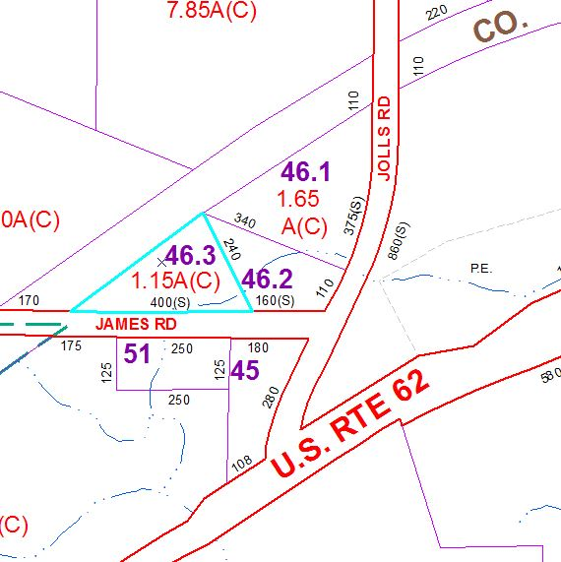

Approximate Yearly Taxes

School $30

Town/County $30

Total $60