Parcel 105

3184 NYS 394 Rte., Town of Cold Spring

|  |  |  |  |  |  |  |  |  |  |  |  |  |
| --- | --- | --- | --- | --- | --- | --- | --- | --- | --- | --- | --- | --- |
| http://maps.cattco.org/Imate/quickstream.aspx?file=VOLLOCAL/Rel2016/042600080001000100900200000002.jpg&thumb=true&width=201&height=152 | | | | | | | **Status:** | | | Active | | |
| **Roll Section:** | | | Taxable | | |
| **Swis:** | | | 042600 | | |
| **Tax Map ID #:** | | | 80.001-1-9.2 | | |
| **Account #:** | | | 5016 | | |
| **Property Class:** | | | 210 - 1 Family Res | | |
| **Site:** | | | RES 1 | | |
| **In Ag. District:** | | | No | | |
| **Site Property Class:** | | | 210 - 1 Family Res | | |
| **Zoning Code:** | | | 01 | | |
| **Neighborhood Code:** | | | 26050 | | |
| **Total Acreage/Size:** | | | 160 x 247.5 | | | | **School District:** | | | Randolph | | |
| **Land Assessment:** | | | 2016 - $6,700 | | | | **Total Assessment:** | | | 2016 - $91,700 | | |
| **Full Market Value:** | | | 2016 - $91,700 | | | |  | | |  | | |
| **Building Style:** | | Ranch | | | **Bathrooms** | | | 2 - 0 | | | |
| **Bedrooms:** | | 3 | | | **Kitchens:** | | | 1 | | | |
| **Fireplaces:** | | 0 | | | **Basement Type:** | | | Crawl | | | |
| **Basement Garage Cap:** | | 0 | | | **Attached Garage Cap:** | | | 676.00 sq. ft. | | | |
| **Year Built:** | | 2000 | | |  | | |  | | | |
| **Structure** | | **Size** | | | **Grade** | | | **Condition** | | | |
| Gar-1.0 attached | | 26 × 26 | | | Average | | | Normal | | | |
| Porch-up covered | | 4 × 8 | | Average | | Fair | | | **Year** | |  | | |
| Porch-covered | | 5 × 12 | | Average | | Poor | | | 1989 | |  | | |
| Milk house | | 16 × 18 | | Economy | | Fair | | | 1910 | |  | | |
| Barn-2.0 dairy | | 0 x 0 | | Economy | | Poor | | | 1910 | |  | | |
| Shed-machine | | 20 x 20 | | Economy | | Poor | | | 1960 | |  | | |
| Quonset hut | | 0 x 0 | | Economy | | Fair | | | 1890 | |  | | |
| Silo-con stv | | 60 x 20 | | Economy | | Fair | | | 1980 | |  | | |
| Barn-2.0 gen | | 0 x 0 | | Economy | | Fair | | | 1955 | |  | | |
| Barn-pole | | 36 x 62 | | Economy | | Normal | | | 1965 | |  | | |
| Porch-open/deck | | 0 x 0 | | Average | | Normal | | | 1940 | |  | | |
| Pool-above grn | | 0 x 0 | | Economy | | Normal | | | 1984 | |  | | |
| Porch-open/deck | | 0 x 0 | | Average | | Normal | | | 1920 | |  | | |
| Shed-galvanized | | 15 x 30 | | Economy | | Normal | | | 2001 | |  | | |
|  |  | | |  | |  | | |  | |  | | |
|  |  | | |  | |  | | |  | |  | | |

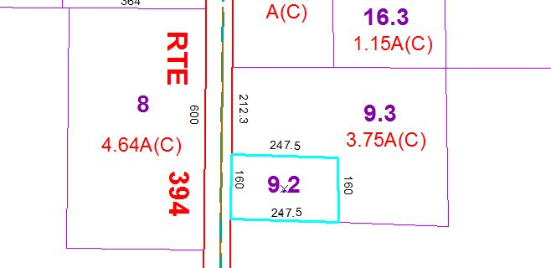

Approximate Yearly Taxes

School $1,019

Town/County $1,462

Total $2,481