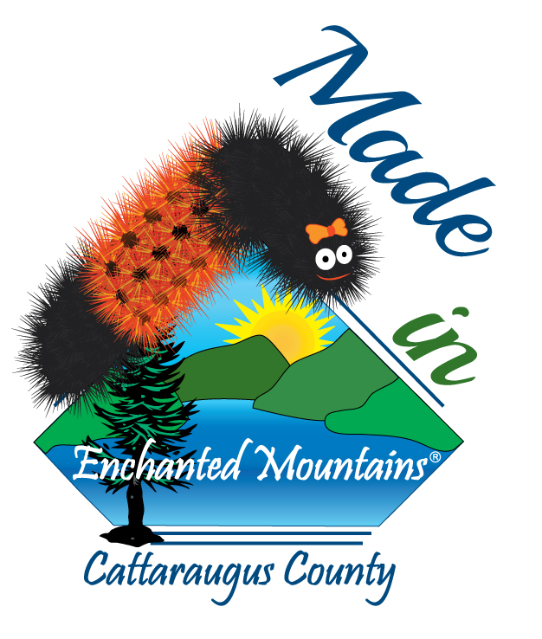
4th Annual WILMA
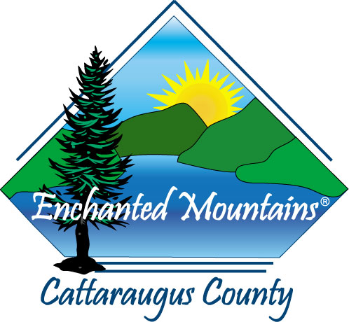
Cattaraugus County Fairgrounds
Saturday & Sunday, October 22nd & 23rd, 2016
(Date is tentative)

If you are interested in applying for a space,
please read through the following information,
complete the enclosed application and mail to:
Cattaraugus County EDPT
c/o WILMA Committee
303 Court Street
Little Valley, NY 14755

By registering for this event, vendors agree to all terms listed below:

Space: Spaces are indoors and the approximate size of each space is 10’x10’
Only available for Cattaraugus County businesses or artisans selling handmade or items
manufactured in Cattaraugus County

Exhibitor Cost: Donation of a door prize “Gift Basket” ~AND~ Registration Fee
$10.00 – Earlybird Registration Fee if registered by August 1, 2016
$20.00 – Registration Fee after August 1, 2016
Make checks payable to Cattaraugus County Tourism
- $30.00 service fee for checks returned due to “non-sufficient funds”

Set Up: Saturday, October 22nd 8:00 am – 10:00 am

Deadline: Deadline for reservations is October 14, 2016

Notice: - Exhibitors will be supplied with one eight (8) foot table and will be responsible for erecting any
other items needed for their area including displays, etc.
- Exhibitors are responsible for reporting the NY Sales Tax where applicable and comply with any applicable State regulations. Exhibitor must clearly display a validated NY Certificate of Authority.
- Vendors will be requested to remain set up for the entire operating times and days of the event.
- Exhibitor understands that exhibits/concessions must be neat and clean, with suitable safety equipment where required.
- Exhibitors are responsible for their own trash disposal which includes large boxes, packing material, signage, etc.
- Exhibitor will stay in its assigned booth space and not occupy/stand in the aisle way or place sign ups/promo items outside of booth space.
- The sponsor will provide the Exhibitor with exhibitor ribbons, which the Exhibitor agrees to use as identification for entrance to WILMA.
- The Exhibitor agrees to obtain and maintain in force, throughout the term of the exhibition, comprehensive general liability insurance against any loss, liability, or damage on, about or relating to the WILMA or the Cattaraugus County Fairgrounds. All such insurance shall name both the Sponsor (Cattaraugus County) and the Exhibitor as the insured parties therein and shall be obtained from a reputable and financially sound insurance company reasonably acceptable to the Sponsor. The Exhibitor shall furnish the sponsor with a certificate of such insurance and a certificate confirming the Exhibitor’s workers compensation insurance coverage, together with written evidence that the premiums for such insurance have been paid, prior to the commencement of the exhibition
- The Sponsor of this event retains the right to decline any application w/just cause. All exhibits must be family oriented – ABSOLUTELY NO exhibits w/pornography, profanity or of vulgar nature. The Sponsor has the right to ask any vendor to remove any merchandise or exhibit that does not adhere to this policy.

Festival Vendor Application

Saturday, October 22, 2016 10 am – 5 pm
Sunday, October 23, 2016 11 am – 3 pm

Name of Organization, Group, Business or Individual:

Address | City | State | Zip

Telephone (Day) | Telephone (Evening)

Fax | Email

Manufacturing Vendor  Craft Vendor  Other  __________________________

Description of Product / Craft / Items you intend to sell / display at your booth:

If you would like to have a booth geared for children’s games or activities or informational or of a non-profit nature, please specify the activity below:
__________________________________________________________________________________________________________________________________________________________________________________________________________________________________________________________________
Please return completed application to: Cattaraugus County Tourism
c/o WILMA Committee
303 Court Street
Little Valley, NY 14755

Hold Harmless Agreement:
Exhibitor releases and holds harmless the facility that is being used, sponsors, owners, managers, merchants associations, agents, servants and employees of Cattaraugus County and Cattaraugus County Fairgrounds from all responsibility, personal liability, loss or damage, theft, fire, loss of life, personal injury and / or damage to property that may arise or occur to exhibitor, his employees, agents, servants, associates, goods, property or the public and from any conditions whatsoever that may arise while the premises are in use, during the show hours or when closed after show hours. We reserve the right to remove exhibitor and exhibits if agreements or rules are not complied with and whose conduct is not acceptable. Misrepresentation on the part of the exhibitor in any form will result in cancellation of space and total loss of fee. Entry constitutes an agreement that exhibitor and his representatives take no legal action against any of the above.

Signature of Exhibitor: _______________________________________________________________________________________
For Office Use Only
Date Received __________________________ Amount Received _________________________________
Check/MO # __________________________ Insurance Certificate _________________________________
Exhibit Lot # __________________________ Exhibitor Packet Sent _________________________________

