**8.0          Submittal Content and Format**

1)      Section II - Qualifications & Experience

a.       Question #9.      Please indicate what is meant by these terms: “network capabilities” and “network modifications”. Strike through delete this item from consideration

2)      Section III – Strategic Planning

a.       Question #3        Does the term “County Benefit Plans” refer to Employee Benefits (i.e. health ins. etc.)? If not, what Benefit Plans are being referenced? Strike through the term “County Benefit Plans”

b.      Question #8        Please clarify what is meant by “network affiliations”. i.e. LeadingAge, NYMIR other organizations that you are affiliated with that aid Counties in the administration of their insurance and compliance needs

c.       Question #11     What is included in the current Risk Management Budget? What is the total current Budget? Are grants included in the Budget? Total budget currently is approximately $600,000 – Includes all premiums and brokerage services.

3)      Section VII

a.       Question #2       Does the County implement a deductible or self-insured approach to liability exposures?  We are self-insured at this time with layers of excess coverages, Commercial Crime and Commercial Property

**9.0          Scope of Work**

4)      3rd Bullet Point: Does this refer to Employee Benefit changes (i.e. The Affordable Care Act)? Already answered above.

Workers Compensation Questions:

5)      Third Party Administrator: will the broker have access to the TPA Claim system? / Who is the current TPA? Yes we have PMA for the WC TPA

6)      Approximate number of open claims/ total incurred value/ average number of Workers Compensation claims filed annually? Open 167



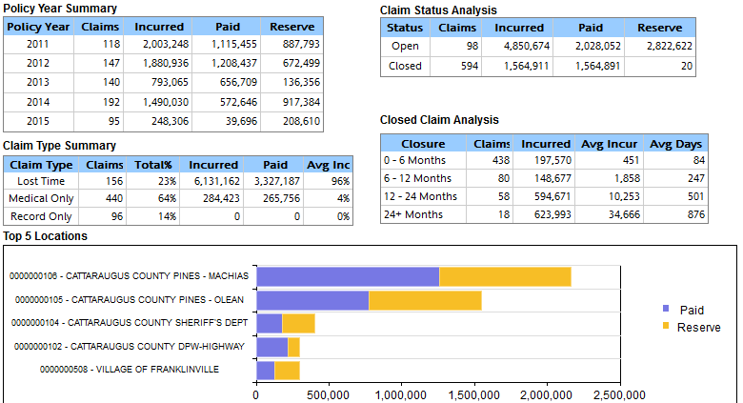

7)      Does the County include benefits under the NYS General Municipal Law Section 207-c in your collective bargaining agreement? Yes

Inquiries on RFP # CCHR2015-1

1. Number 9.0, Scope of Work, Point 7: Requests information about the use of an independent auditor for claims review. Does the county select this auditor or the Agent of Record? The county will consider recommendations for independent auditor; however, the county will choose the independent auditor.

2. Who currently designates legal counsel for items that are below the SIR level? Would you need a successful broker to be involved in that process? Currently the County Attorney handles or designates counsel for all items up to the self-insured limit. The county does notify carrier of all claims at time received well in advance of cases reaching the excess coverage limits.

1. Is a Summary (or Schedule) of Insurance available for review? Please include carriers, policy data and premiums. Reason for request: To construct a viable fee proposal using a combination of commissionable policies and a Risk Management fee schedule.

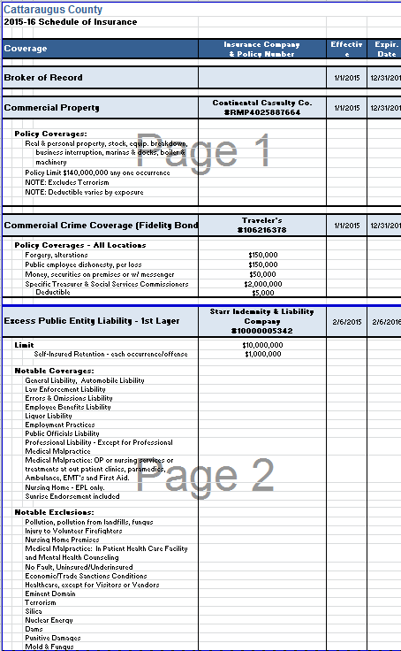

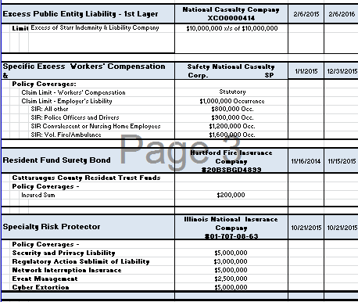

1. What services/products are included in your $90,000 Risk Management budget?

Correction the total budget is just under $600,000.

1. Can we assume that this call replaces the June 15 pre-proposal meeting listed in 3.0 on page 4 of the RFP and that there will not be a subsequent meeting? Yes, however, if you feel the need for further clarification, please email me at [jjcarr@cattco.org](mailto:jjcarr@cattco.org) and I will post replies to the website.
2. What type of 'monthly reconciliation reports' are you referring to? - Loss Runs? Section IV Q 8 Monthly reporting to review where we are in relationship to Risk Mitigation and Safety Training goals. If we have tasks that need to be completed and to review changes that may have occurred during the month that will impact shopping for our coverages in the annual renewal process.
3. Is PMA also the TPA for the liability as well as the WC claims? No PMA is strictly Workers Compensation.
4. Under scope of work - bullet #8 ~Ability to transfer funds for payment of claims in compliance with Cattaraugus County privacy laws (ASSUME this is to be stricken as it seems like a BENEFITS question?) Correct

Attached is the required receipt confirmation form. The RFP contains 50 interrogatives, 13 scopes of service, 6 references, and 4 deliverables.  Many of the interrogatives and scopes of service regard benefits services and TPA services not described in the RFP.

Scopes of Services

Bulleted item 3 - strike word benefit replace with regulatory

Bulleted item 8 - removes or strikes out entire item

Regarding References-- Provide valid references as many as 6 if you do not have that much experience state so in your response this will not in and of itself disqualify a proposal.

Regarding Benefit Services – Benefit services should be referenced in regard to Risk Mitigation and Safety training services for an employee population of 1395 or greater provided either by your firm or by a TPA or Insurance Provider as part of their premium being paid.

TPA services may be the best option for Safety and Regulatory Mandatory Annual Training services to facilitate compliance for all of our departments.

1)      Is a Summary Schedule of Insurance available for the program currently in place? Yes see above