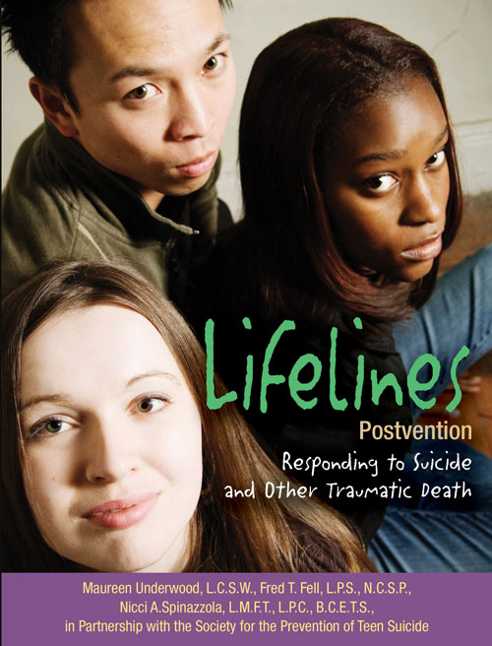
School-based response to Suicide and Traumatic Death
A Lifelines Workshop for School Crisis Teams

Goal: This one day training helps school crisis teams review current
procedures for suicide and other traumatic deaths in the school community. The strategies presented are designed to respect the critical role of the school in the recovery process and provide support, control, and structure to maintain order while assisting in the grieving process of school community members. The workshop is based on the Lifelines Postvention Model which is on the National Best Practices Registry of the Suicide Prevention Resource Center and American Foundation for Suicide Prevention.

The Presenter: Maureen M. Underwood, LCSW, is the lead author of Lifelines Postvention. With over 35 years of experience in assisting schools in the postvention process, Ms. Underwood brings a wealth of experience to assist schools in adapting training content to their specific resources and needs.

Who should attend? School staff members who have a key role to play in responding to a death by suicide or other sudden death: administrators, pupil assistance coordinators, nurses, school counselors, social workers, and other appropriate staff. Community partners who may assist schools are also encouraged to attend.

Objectives: Participants will be able to:
- Describe the history and evaluation results of Lifelines Postvention.
- Clarify the role of the school administrator in postvention.
- Outline the roles and responsibilities of the crisis team.
- Customize templates and tools to meet the unique needs of their school
- Develop a process for responding compassionately and appropriately when faced with the death of a student

Date: Wednesday, November 7, 2012 Time: 8:00am to 3:00pm
Location: 987 R.C. Hoag Drive Salamanca, NY Lionel R. John Health Center- Grand Hall
To register: Call Meghan Monahan at 716-701-3315 or e-mail Mcmonahan@cattco.org
Questions: Please contact Meghan Monahan, registration deadline: Wednesday October 31

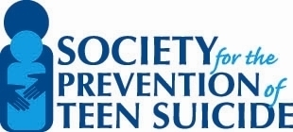
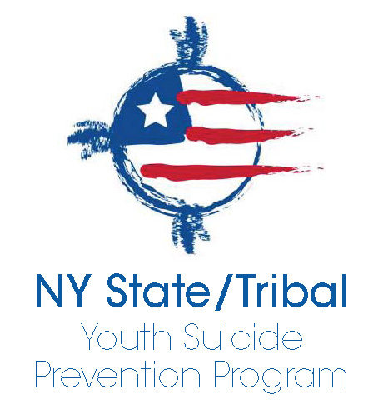

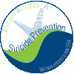
This training is provided through the support of the New York State Office of Mental Health through the Garrett Lee Smith Youth Suicide Prevention Act, the Suicide Prevention Coalition of Cattaraugus County and the Early Identification & Recognition Program of Cattaraugus County Department of Community Services.
