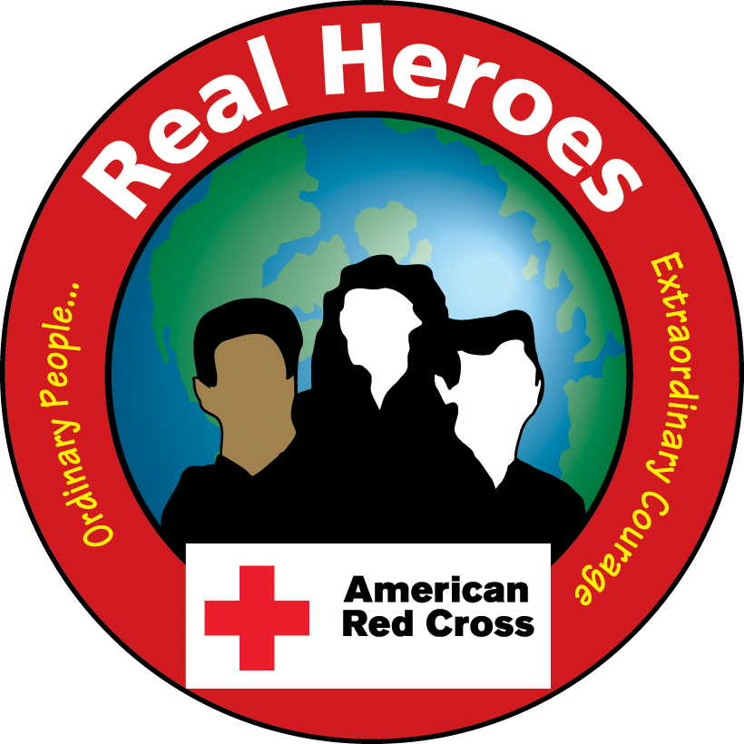

*The American Red Cross is calling for nominations*

*of everyday people in your community*

*who have gone above and beyond*

*to change the life of another!*

Hero Categories

***Lifeline / 9-1-1***

***Animal Rescue***

***Educator***

***Fire Rescue***

***Good Samaritan Adult***

***Good Samaritan Youth***

***Good Neighbor***

***Workplace/Industrial Safety***

***Law Enforcement***

***Medical***

***Military***

***Blood Donor***

If you know someone who has, in the last year, carried out an unselfish act of *Heroism* to help change the life of another, we want to recognize them at our Hometown Heroes Breakfast!

Here’s How to

Nominate a Hero:

Fill out nomination form and submit via mail or email:

American Red Cross

Hometown Heroes Nominations

325 E. 4th Street

Jamestown, NY 14701

Lyman_N_Buck@KeyBank.com

*More Info/ Obtain Form:* call716-485-2524.

*Website (coming soon!): www.redcross.org/HometownHeroes*

*Deadline for submission: May 1, 2016*

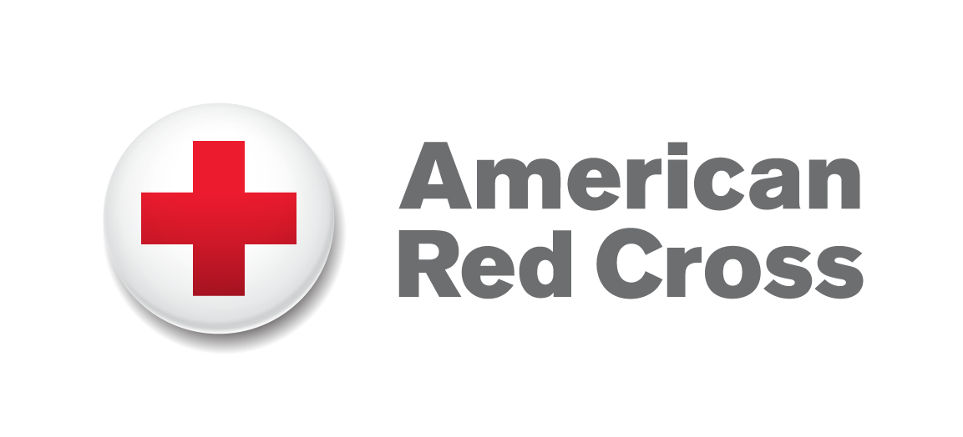

**Please Print and Display**

2016 American Red Cross Real Heroes Breakfast Nomination Form

The life-changing action must have taken place during the period of June 22, 2015 to April 30, 2016.

Award Categories (Please Check One)

□ Good Samaritan Youth

□ Good Samaritan Adult

□ Educator

□ Military

□ Medical

□ Animal Rescue

□ Good Neighbor

□ Blood Donor

□ Fire Rescue

□ Workplace /Industrial Safety

□ Lifeline / 9-1-1

□ Law Enforcement

**Category Descriptions**

|  |  |
| --- | --- |
| Good Samaritan: | Presented to an ordinary citizen who used life-saving skills to save the life of another. Adult or Youth. |
| Educator Hero: | Presented to an educator who used life-saving training to save the life of another. |
| Military Hero: | Presented to a member of the Armed Forces (active or retired, commissioned or non-commissioned) whose life-saving actions exemplify the very highest standards of their calling. |
| Animal Rescue Hero: | Presented to the family of a pet who was instrumental in saving a life. |
| Good Neighbor: | Presented to an ordinary citizen or professional rescuer involved in rescuing a person from a life-threatening situation. |
| Fire Rescue: | Presented to a firefighter, volunteer or paid, whose life-saving actions exemplify the very highest standards of their calling. |
| Workplace /Industrial Safety: | Presented to a business owner, manager or employee whose preparedness or life-saving action exemplifies the very highest standards of their calling. |
| Lifeline / 9-1-1: | Presented to a 911 dispatcher whose life-saving action exemplifies the very highest standards of their calling or and ordinary citizen who was involved in saving the life of another by using 911 Emergency Communications. |
| Law Enforcement: | Presented to a law enforcement officer whose life-saving action exemplifies the very highest standards of their calling. |
| Medical Hero: | Presented to a medical professional, an organization, or an ordinary citizen whose life-saving action exemplifies the very highest standards of their calling. |
| Blood Donor | Presented to an individual who has contributed an outstanding amount of blood or blood products to the American Red Cross blood bank. |

Nominee

|  |  |  |  |  |
| --- | --- | --- | --- | --- |
| First Name: |  | Last Name: |  | |
| Street Address: |  | Email: |  | |
| City/State: |  | Zip Code: |  | |
| where rescue took place: ____________________________ | |  | | |
| Phone (Daytime): |  | Phone (Evening): | |  |

Nominator

|  |  |  |  |  |
| --- | --- | --- | --- | --- |
| First Name: |  | Last Name: |  | |
| Street Address: |  | Email: |  | |
| City/State: |  | Zip Code: |  | |
| Phone (Daytime): |  | Phone (Evening): | |  |

Nomination Statement **-** Please state why you are nominating the candidate for the 2016 American Red Cross Hometown Heroes Award; if additional space is needed, please use extra sheet. Date of Rescue, when applicable: __________________

|  |
| --- |
|  |
|  |
|  |
|  |
|  |
|  |
|  |

Please Mail, Email, or Fax this completed form by May 1, 2016 to:

American Red Cross, Western New York Chapter | 325 E. 4th Street | Jamestown, NY 14701

Email Address: Lyman_N_Buck@KeyBank.com | Phone: 716-485-2524

Fill out and submit online at: **www.redcross.org/HometownHeroes**