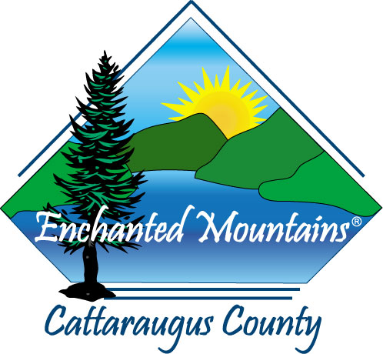
REQUEST FOR PROPOSALS

County of Cattaraugus

Cattaraugus County Site Redevelopment Assessment

A. OBJECTIVE

The County of Cattaraugus is soliciting proposals from qualified consultants to prepare feasibility studies to return three (3) obsolete manufacturing facilities to a condition that will support advanced manufacturing (or other use), private investment, job creation, and economic development throughout the County.

B. BACKGROUND INFORMATION

Cattaraugus County is a rural county located in southwestern New York State. The County has historically had a strong manufacturing base. However, abandonment of manufacturing facilities in previous years has resulted in decaying buildings and localized blight within communities. Cattaraugus County would like to reverse the trend of facilities abandonment and promote the establishment of new businesses through the reuse of abandoned manufacturing sites.

C. PURPOSE

The goal of the Site Redevelopment Assessment is to evaluate the feasibility of returning three identified properties to functional use. The locations of these sites and estimated sizes are: 1) Ellicottville – 1.45 acres, with structures; 2) Franklinville – 3.52 acres, with structures; and 3) Gowanda – 1.8 acres, with structures (see attached general location map). Final deliverables will permit the County and prospective business interests to determine the extent of environmental site remediation and structural repairs/demolition required to return each property to a functional use.

D. SCOPE OF SERVICES

Cattaraugus County will provide Phase II Environmental Site Assessments (ESA) for each of the three properties being evaluated. By examining the ESA’s and visiting individual sites, the consultant will determine the extent of environmental and on-site improvements remediation required to permit the safe return of subject properties to productive use. This review must be sufficient to permit prospective parties interested in taking title to any of the subject properties to do so with confidence that all known and potential environmental liabilities and structural issues, and their remedies, are adequately and thoroughly addressed in the study.

Primary assessment components will include, but will not be limited to:
- Description of individual sites.
  - Positive and negative attributes.
- Description of acceptable environmental remediation actions and how these satisfy site requirements for reuse.
- Description of structural deficiencies of all improvements and the requirements to bring same into conformance with New York State building codes (including demolition, as appropriate).
- Cost estimates of environmental remediation and structural compliance issues by listed action(s).
- Recommendations on potential future uses.

E. PROJECT ORGANIZATION AND COORDINATION

The Cattaraugus County Department of Economic Development, Planning, and Tourism (CCEDPT) will oversee the completion of the assessments. CCEDPT will meet with the consultant on an as-needed basis to provide direction, and will be responsible for project management and grant administration.

F. TIME FRAME

Pursuant to the contract between Cattaraugus County and Empire State Development, all project work must be completed by March 15, 2018.

G. PROPOSAL SUBMITTAL

If your firm chooses to submit a proposal in response to this RFP, please follow the instructions below:
- Proposal Format
Your proposal should include the following:

a. Statement of Qualifications

For project participants, please document relevant experience with remediation of sites with environmental contamination concerns and structural issues, and provide personal resumes of the project team. Provide references for similar projects.

b. Services

Please provide each of the following items:
1) A proposed scope of services or work program
2) Your methodology for completing the study
3) A proposed time schedule and project work sequence
4) Proposed project team and organization

5) Description of any proposed subcontracting
6) Statement of availability to meet with CCEDPT to present findings, analysis, and recommendations after completion of the assessment.
7) A description, and number, of copies of reports and materials to be provided (i.e. digital copies of text, tables, illustrations, etc.)
- A minimum of three client references, including contact persons and phone numbers.

The consultant that is selected will be expected to assist in developing a final scope of services to incorporate into the contractual agreement with Cattaraugus County.

c. Cost Estimates

The proposal shall include the cost for the services requested, not to exceed Seventy Five Thousand and 00/100 Dollars ($75,000.00). The fee for each element shall be specified with a tentative payment schedule including provisions for Cattaraugus County to retain 10% until completion of all aspects of the contract.

- Submittal of Proposal

Please submit three (3) paper copies and one jump drive digital copy of your proposal to:

Crystal Abers, Director
Cattaraugus County Department of Economic Development, Planning and Tourism
303 Court Streets
Little Valley, New York 14755

- Submittal Deadline

All proposals and any supporting materials must be received no later than 5:00 p.m. on December 8, 2017.

- Proposal Conditions

  - Compliance with Cattaraugus County standard Appendix A, which is attached to this Request for Proposal (RFP), is required.
  - All materials produced under this contract shall be the sole property of Cattaraugus County.

H. CONTACT PERSON

If you have any questions regarding this Request for Proposals (RFP), or would like additional information prior to preparing your proposal, please contact:

Patrick McGlew, Development Specialist
Cattaraugus County Department of Economic Development, Planning and Tourism
303 Court Streets
Little Valley, New York 14755
Telephone: 716-938-2387
E-mail: PJMcglew@cattco.org

