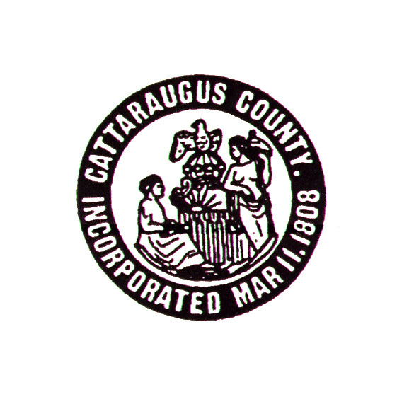

CATTARAUGUS COUNTY

DEPARTMENT OF SOCIAL SERVICES

One Leo Moss Drive, Suite 6010 Olean, New York 14760
(716) 373-8070

DANIEL PICCIOLI Evonne Phillips

Commissioner Director of Services
ANTHONY TURANO Paula Falkner

Deputy Commissioner Case Supervisor

FOR IMMEDIATE RELEASE December 31, 2015

Have you ever thought about opening your home to a child in need? Would you like to change the life of a child in your community?
If you have ever thought about becoming a foster parent, the Cattaraugus County Department of Social Services will be holding an informational meeting on Monday, January 11, 2015, from 5:30 PM to 7:00 PM. The meeting will be held at the Department of Social Services located at One Leo Moss Drive, Olean, NY 14760.
The purpose of the informational meeting is to provide information to all families that have expressed an interest in being foster care/adoptive resources for children within the community. Social Services staff will be on hand to explain the options and the certification process. Please attend the meeting and feel free to ask questions that you may have regarding the certification process.
We hope to see you there.
For more information and to RSVP for the meeting, please contact Foster Home Finder/Adoption Caseworker Kayla Chesebro at 701-3664.

